Deploying Greenhouse Gas Reduction Fund Capital:

A Challenge in Fiscal Federalism

Northeast-Midwest Institute

By Policy Research Intern Charlotte Sadelain

Edited by Thomas H. Cochran, Senior Fellow for Public Finance Policy

November 2023

Executive Summary

The Inflation Reduction Act of 2022 will create and allocate funds to a vast array of new financing programs supporting the development of clean energy and energy efficiency projects, as well as reinvigorate many other existing programs with increased funding. Some of these programs can accommodate the needs of small and medium- sized enterprises (SMEs), which will carry out a range of important manufacturing, installation, and maintenance functions in the U.S. clean energy transition. In the past, the federal government has successfully supported SMEs through financing partnership programs with the states, which are better positioned to interface with smaller, locally or regionally based businesses.

The Greenhouse Gas Reduction Fund (GGRF) administered by the U.S. Environmental Protection Agency (EPA) will provide $27 billion to several state and non-profit entities to invest in new clean energy technology, generation, and supply chain projects across the U.S., largely through financing of SME-sponsored projects. The innovative GGRF implementation framework crafted by the EPA seeks to carefully balance leniency and oversight in order to achieve Congressionally mandated clean energy goals while respecting state autonomy. By design, the GGRF framework will support businesses and help achieve networks of funding streams even in unsympathetic states by making non-profits, municipalities, and other entities that are capable of effectively and responsibly partnering with project developers as ultimate eligible end-use recipients. Going forward, delivering on an equitable and coordinated approach will require excellent oversight from EPA and surmounting the challenges of personnel shortages and political efforts to curtail the program through the appropriations process. Presently, stakeholders around the country must urgently coordinate to capitalize on this opportunity to accelerate the clean energy transition.

Beginning in 1977, the Northeast-Midwest Institute (NEMWI) has researched ways in which the federal government could and does assist 18 states (as well as the rest of the country) to reduce both the costs and the negative environmental impacts of their energy sources and uses. In the 1980’s, NEMWI authored and published a “Users Guide to Government Energy Programs” that helped constituents and private sector partners understand how to access and most effectively use the 55 distinct financial and/or technical assistance energy programs offered by 18 federal agencies at the time. This report continues in that tradition by focusing on just the GGRF program as it starts its life in a vastly changed federal energy policy and public capital investment fiscal policy environment 41 years after the publication of that guide.

Table of Contents

Page Number

Introduction …….. 3

Overview ……... 5

Fiscal Federalism ……… 7

Other Challenges ………. 11

Conclusion ………. 12

References ………. 13

Appendix A ……….. 15

Appendix B ……….. 17

Appendix C ……….. 20

Appendix D ……….. 24

Appendix E ……….. 27

- Introduction

The Inflation Reduction Act of 2022 (IRA) recognizes the central role that states must play as pivotal financial intermediaries in the clean energy transition. A total of 35 clean energy programs - 22 newly created and 13 pre-existing but provided with increased levels of funding - are envisioned to be carried out entirely or partially by cooperating state agencies (see Appendix A). The programs cross sectors, from renewable energy generation to transportation to housing to transmission siting, all of which are subject to President Joe Biden’s Justice40 mandate, which requires that 40% of overall benefits from federal investments flow to disadvantaged communities (i.e. marginalized, underserved, and/or overburdened by pollution). The largest amount of the entirely new funding, $27 billion, will go to and through the EPA-administered Greenhouse Gas Reduction Fund (GGRF), a program which will ultimately help finance tens of thousands of clean energy projects across the U.S. Many of those projects will be developed, sponsored, and/ or executed by small and medium- sized enterprises (SMEs).

SMEs create and carry out clean energy technologies and projects, thereby reducing emissions, while providing valuable services to consumers and communities. Clean energy supply chain manufacturing, generation, and distribution project developers operating through SMEs can tailor their products and projects to fit the nation’s widely varying political, economic, and regulatory circumstances on local and regional scales. Historically, given its large size and scope, the federal government has struggled to help finance SME-sponsored clean energy projects. Instead, more well-resourced programs have been created that are geared toward larger, innovative commercially-unproven technology projects seeking to demonstrate their technical and economic viability and utility-scale projects using commercially proven technologies. Most notably, the Department of Energy’s (DOE) Loan Programs Office (LPO) has successfully run a clean energy debt financing program for relatively large projects sponsored by credit-worthy firms referred to as Title 17 since 2005 (see Appendix B).

Due to their typically less well-capitalized and less credit-worthy status compared to larger companies, SMEs stand to benefit the most from government aid in the form of financial and technical support but are the least prepared to overcome financial and bureaucratic barriers to attaining those benefits. Financial and technical support for smaller commercial and non-profit clean energy enterprises that lack vast financial resources to succeed is also essential for advancing equity goals since those entities are more likely to be run by and serve members of disadvantaged communities.

For the Federal government, reaching qualified recipients most in need of assistance while conducting the vital due diligence and monitoring the use of public funds requires collaboration with knowledgeable and financially competent conduit entities. State and local governments, as well as non- and for-profit financial intermediaries, have a crucial role to play in meeting this challenge. As smaller scale governments with robust resources and closer ties to local communities, states in particular have long played a pivotal role in developing infrastructure and delivering basic services to their constituents, often in some form of financing partnerships with the federal government. These public financing relationships helping capitalize many of essential public infrastructure projects have taken a prominent place in the increasingly complex American system of fiscal federalism.

One highly successful example of a federal-state financing partnership initiative aimed primarily at assisting small and medium-sized environmental projects is the Clean Water State Revolving Fund (SRF) program. Since 1987, EPA has provided formula-based loan fund capitalization grants to states, which in turn use the money to provide low-interest loans to hard-pressed and typically less creditworthy local government sewer and water agencies for the development of critical wastewater treatment water-supply infrastructure. The flexibility built into the SRF program allows each state to make decisions about which projects they will help finance, as well as tailor their loan terms to meet community financial needs. In addition, it takes the burden off EPA, a federal bureaucracy, from having to coordinate, meet with, and conduct in-person due diligence and loan monitoring work with stakeholders across all the states, vastly reducing EPA administrative costs. To date, CWSRF programs have underwritten more than 44,500 affordable loan agreements throughout the U.S., including 30,100 in small, often fiscally strapped communities of fewer than 10,000 people, helping in the financing of over $163 billion in project costs. Nation-wide, water supply and sewerage treatment loan default rates experienced by SRFs have been extremely low: i.e. in the 0.2% range.

With respect to federal programs explicitly centered on the deployment of clean energy technologies, programs that both pre-date the Inflation Reduction Act (IRA) and are capable of targeting small businesses are relatively few. Many are narrow in scope and only available to businesses within specific sectors, such as the Department of Agriculture’s Rural Energy for America Program, which provides financial assistance to farmers and rural businesses to purchase renewable energy systems, conduct energy audits, and make efficiency improvements.

More generally, the Small Business Administration (SBA), an independent federal agency, offers long-term loans to for-profit companies with a net-worth of less than $15 million to carry out different kinds of commercial activities, including the improvement or modernization of utilities, generation facilities, and manufacturing in the clean energy supply chain space. However, to date, federal programs supporting the deployment of clean energy projects of small businesses have been implemented in piece-meal fashion, motivated by different events and in pursuit of separate goals.
DOE only recently unveiled numerous programs across different sectors explicitly aimed at small and medium- sized public non-profit and commercial entities and individuals, many of which are administered by the Office of State and Community Energy Programs.
Since its founding in 1977, the Northeast-Midwest Institute has researched ways in which the federal government could and does assist 18 states (as well as the rest of the country) to reduce both the costs and the negative environmental impacts of their energy sources and uses. In the early 1980’s, NEMWI published a widely distributed “Users Guide to Government Energy Programs,” summarizing federal initiatives which had been enacted to help public and private sector actors to make a transition to use of non-fossil-fueled electrical generation technologies (See Appendix C). This 1982 publication, intended for Congressional staff, Governors offices, non-profit organizations, journalists, and others, supported engagement with constituents and private sector partners to understand how to access and most effectively use 55 distinct financial and/or technical assistance programs offered by 18 federal agencies. In the context of this paper by Policy Research Intern Charlotte Sadelain (Dartmouth College, ’26), it is particularly interesting to note that the U.S. Environmental Protection Administration (now the Environmental Protection Agency (EPA)) was not among the federal agencies offering any energy transition-related financing and/or technical assistance programs. The landscape of these programs offered within the nation’s complex and ever-evolving system of fiscal federalism has changed remarkably. Exhibit A: today, the highest-funded new federal program designed to help speed up clean energy generation, is the Greenhouse Gas Reduction Fund (GGRF) being administered by the EPA.

- Overview: The Greenhouse Gas Reduction Fund

The Greenhouse Gas Reduction Fund (GGRF) provides $27 billion to the Environmental Protection Agency (EPA) to help finance smaller-scale clean energy and climate projects through partnerships with state government and non-profit development finance entities such as green banks, state economic development authorities, community development finance institutions (CDFIs), and more. Direct recipients will be selected through three concurrent grant competitions, rather than through formula-based grants as the agency has been accustomed to doing in the SRF program.

The program’s three Congressionally-mandated objectives are to:
- Reduce emissions of greenhouse gasses and other air pollutants;
- Deliver benefits to communities; and
- Mobilize private capital to deploy clean energy projects.

- Solar for All

The first of the three programs offered through the GGRF, “Solar for All”, makes $6 billion available to fund up to 60 grants for states, territories, municipalities, tribal governments, and eligible non-profits, which commit to expanding the number of families with access to affordable, clean solar energy in low-income and disadvantaged communities. Grant applicants must demonstrate how they intend to establish or improve Solar for All program elements, including residential rooftop and community solar PV projects, grid infrastructure, and associated storage capacity. EPA has stated that it will consider that a project delivers benefits to households with solar PV if it helps recipients to directly receive solar generated electricity, subscribe to a community solar program, or otherwise “meaningfully improves the lives of households” through programs such as workforce development and consumer awareness initiatives.

Applicants may apply individually or as part of a cohort with an eligible lead entity. Within states, agencies such as housing authorities, municipal utilities, rural cooperative utilities, and public institutions of higher education are examples of eligible applicants. If more than one agency within a single unit of government (state, municipality, territory, or tribe) submitted a Notice of Intent (NOI) to apply, EPA will notify the agencies to encourage coordination among instrumentalities working within the same jurisdiction. They also encourage coordination among municipalities in the same state and among municipalities within states in which a state agency intends to participate since EPA intends to award only one grant per geographic area, whether a state or territory. This demonstrates one of the program’s central aims: to maximize its geographic coverage across the U.S. and avoid duplicative efforts within a given area.

Grants will range from $25 million to $400 million, and partial grants may be awarded. Once grants are awarded, likely in July 2024, grantees will begin providing assistance to eligible entities. Assistance may take a wide range of forms, including subgrants, rebates, subsidies, loans, loan guarantees, incentive payments, and project-deployment technical assistance. In response to EPA’s Request for Applications, applicants must have filed a Notice of Intent (NOI) prior to completing a full application. States’ notices were due on July 3, 2023, followed by territories, municipalities, and eligible nonprofits on August 13, 2023, and August 28, 2023 for tribes. The full application deadline for all applicant categories was September 26, 2023.

- National Clean Investment Fund

Second, the “National Clean Investment Fund” (NCIF) will funnel $14 billion in capital into 2-3 non-profit organizations that can partner with public (state or local government affiliated) and private for-profit and non-profit sector debt and equity capital providers to help finance many smaller clean energy projects. Eligible recipients must be nonprofits designed to provide capital, leverage private capital, and provide financial assistance for the deployment of low/ zero emission technologies. Further, eligible entities cannot take deposits, must be publicly or charitably funded, and have the legal authority to invest in projects. The selected recipients, alongside any identified coalition application members, will then be responsible for investing in qualified emissions and air-pollution reducing projects that deliver benefits to American communities by providing financial and non-financial support to project developers, including project sponsors, individuals and households, for-profit businesses, and community lenders.

Direct competition recipients may only help sub-awardees to develop and complete eligible projects that meet EPA’s six requirements: (a) reducing or eliminating GHG emissions and (b) other air pollutants directly or by assisting community efforts to do so, (c) alleviating conditions associated with 2 or more of the following: climate change, energy, public health, housing, legacy pollution, transportation, water and wastewater, and workforce development, (d) leveraging private capital, (e) be commercially available technologies, and (f) be projects that may not have been financed otherwise. In addition, the program will prioritize the following three project categories: distributed energy generation and storage, net-zero emissions buildings, and zero-emissions transportation, meaning EPA will favor applications in which those categories are given precedence.

Recipients will also be required to follow the President’s Justice40 mandate, ensuring that 40% of benefits flow to disadvantaged communities. Disadvantaged communities are determined as either those identified by the CEJST mapping tool, EJScreen mapping tool, geographically dispersed low-income households, or properties providing affordable housing. Applications were due October 12, 2023.

- Clean Communities Accelerator

Finally, the “Clean Communities Investment Accelerator” (CCIA) competition will disseminate grants totaling $7 billion to 2-7 non-profits that will then build the clean energy funding capacity of public, quasi-public, and non-profit entities such as Community Development Finance Institutions (CDFIs), credit unions, green banks, housing finance agencies, and minority depository institutions. One hundred percen of the funds from this program must be used to deploy projects in and provide benefits to low-income and disadvantaged communities, households, and schools. Grantees themselves, as well as any other members included within a coalition application, may not use the funds themselves to deploy eligible projects. Additionally, CCA grantees must demonstrate that they are able to strengthen the financing capabilities of community lenders on a national scale, across all 10 EPA regions.

Sub-awards, whether in the form of financial or technical assistance, may only be utilized by selected sub-awardees (i.e. community lenders and similar institutions) to help finance projects that (a) meet the qualified projects definition, which is the same as in the NCIF competition, (b) fall within a priority project category, also the same, and (c) are based in and benefit low-income and disadvantaged communities. Applications were due October 12, 2023.

- Implementation Framework: A Challenge in Fiscal Federalism

In the post-World War II era, the U.S. system of fiscal federalism in which responsibilities are divided and shared among federal, state, and local governments “to optimize economic efficiency and utility while achieving public policy objectives” has evolved with particular speed into today’s complex form encompassing both various forms of public capital investment (e.g. GGRF, The Highway Trust Fund, etc.) and social program operating funds (e.g. Medicaid SNAP, etc.). In this highly decentralized system, varying political, economic, and cultural contexts profoundly influence how federal programs are implemented across different jurisdictions. Depending on voters’ priorities, bureaucratic systems, and available resources, the same federal program may be deployed far more successfully in some places than others. It follows that a major challenge for the federal government, in this case EPA, is creating and successfully implementing a framework under which quality and a degree of consistency can be enforced without unduly restricting state governments.

- The State Context

Different types of state agencies are eligible to apply as lead or coalition member applicants in all three EPA administered GGRF grant award competitions so long as they have the desire and necessary personnel capacity and expertise to do so. In order to better understand states’ level of preparedness to support the efficacious implementation of the GGRF, this NEMWI policy research project initially sought to learn what actions states, state agencies, and non-profits in the Northeast-Midwest region have already taken that would presumably strengthen their ability to qualify for and effectively support new clean energy projects using capital flowing from the GGRF. It sought to standardize an approach to assessing states’ preparedness and develop a scoring system to compare states and make recommendations by looking at the following two criteria.

    - Presence of Green Banks

According to the Coalition for Green Capital, an interest group that represents entities which help finance clean energy and energy efficiency projects (and which itself has publicly announced its intent to apply for GGRF capitalization grant funding), a green bank is a “mission-driven institution that uses innovative financing to accelerate the transition to clean energy and fight climate change.” They do not function as normal banks in which customers deposit money; rather, these are independent financing authorities that use innovative financing structures and market expertise to mobilize private investment into various climate-related sectors. Most are public or quasi-public entities with ties to state government, meaning that seed capital is provided by public funds, either authorized through legislation or by gubernatorial executive order. Often, central to their mission is reducing emissions and/or energy costs, mobilizing private capital, lowering the cost of capital, developing green technology markets, and job creation. Sometimes they are created with more narrow targets in their sights: one good example is Massachusetts’ new green bank focused on developing affordable, climate-friendly housing. According to the Coalition for Green Capital’s Annual Report, in 2022, American green banks responding to its survey invested $1.51 billion of their own capital alongside $3.12 billion in private debt and equity investment to deploy clean energy projects, totaling $4.64 billion of investment in a single year. Since 2011, private-public investments mobilized through responding green banks have reportedly surpassed $14.85 billion. Partnering with existing public and private development finance institutions that are currently funding clean energy generation, supply chain manufacturing, and /or transmission projects is central to the mission of the overall $27 billion Greenhouse Gas Reduction Fund Program.

    - Existence of Competent State Agencies and Authorities

States confront a unique set of challenges in the face of climate change since each one possesses unique geography, different demographics and population sizes, economic systems with a varied mix of different industrial and commercial sectors, and contrasting distributions and availability of natural resources. It can be difficult and not necessarily useful to directly compare programs offered by agencies working to mitigate climate change across different states. Where one state may need to prioritize financing the transition of coal-reliant communities, such as Illinois, another state may be far more concerned about decarbonizing residential and commercial buildings, such as New York. Therefore, having power generation and distribution regulatory structures, programs, and agencies with different scopes and aims may be entirely reasonable and efficient. Refer to Appendices D for a high-level overview of the regulatory context of the clean energy transition from the regional perspective in the Northeast and Midwest.

Instead, the study sought to use the existence, or lack thereof, and the specificity of states’ Climate Action Plans as a proxy for determining state officials’ level of engagement with maintaining up-to-date and efficient climate programs. By building on existing programs that focus on deploying projects which meet the GGRF’s eligibility requirements, some states agencies are presumably already better positioned to serve as competent conduits of the federal capital. Climate Action Plan Quality Indicators initially researched included:
- when the plan was last updated, and
- whether it addresses relevant sectors central to IRA programs, including clean energy, transportation, housing, transmission, infrastructure/materials, air quality, conservation, and social equity.

See Appendix E for a table summarizing the status of six New England states’ policy and institutional development in this area.

Notably, both Massachusetts and New Hampshire have taken major action to step up their climate mitigation capabilities in response to the passage of the Inflation Reduction Act. In New Hampshire, which currently has no codified state climate action plan or binding emissions reductions targets, the Department of Environmental Services adopted a two-year $15.2 billion budget plan in June to author and implement a new climate action plan. The decision to move this plan forward was motivated by the availability of federal funding provided through the Climate Pollution Reduction Grant program. This could be enormously important given that New Hampshire has long been an outlier in the region regarding climate action. Also in June 2023, Massachusetts Governor Maura Healey announced the creation of a new green bank dedicated to affordable housing with an initial endowment of $50 million provided by the state’s Department of Environmental Protection. This entity was apparently created explicitly for the purpose of attracting federal funds made available under the Inflation Reduction Act.

In places where voters and special interest groups are opposed to public spending for renewable energy projects and/or other climate change mitigation measures, the GGRF may be met with opposition at the state level. For instance, Florida has declined to file an NOI to apply for both the Climate Pollution Reduction Grants and “Solar for All” programs. While all eighteen states of the Northeast-Midwest region have qualified, the five states of Florida, North Dakota, South Dakota, Nevada, and Montana, did not fulfill the preliminary NOI requirement to participate in “Solar for All,” disqualifying them from applying to receive any of the grant money set aside for their states. However, the impact on the success of the GGRF in these states may be minimal since municipalities, non-profits, and community lenders are also eligible conduits for deploying capital across all three GGRF grant award competitions.

- Navigating the Fiscal Federalism of Public Capital Investment

Under the implementation framework of the GGRF, the EPA - an agency with little evident prior experience in providing financial assistance to accelerate the clean energy transition - was given full reign over determining the best approach to dividing responsibilities among government and non-government entities to achieve the aims of the program. On close examination,
it became clear that EPA’s announced GGRF competition framework tries to ensure that the benefits of the program reach all sectors and states, including those that have shown complacency or even hostility towards government climate-related programs by allowing multiple types of organizations to apply while conducting centralized federal oversight.

EPA explicitly created specific application requirements and evaluation criteria across all three competitions compelling recipients to maximize the geographic span of their efforts. The “Solar for All” competition makes a single winning entity or small group of winning entities across every state and territory responsible for partnering with non-profits, the private sector, and individuals within their area to deliver the benefits of solar energy to low-income households. Under the frameworks of the “National Clean Investment Fund” and “Clean Communities Investment Accelerator” competitions, winners will be selected on how explicitly and convincingly they can put forth a strategy to partner with project developers and community lenders in states around the country, regardless of their own local base. Consequently, states like Florida should not be able to evade the downstream effects of the GGRFs so long as well-qualified non-profits, community lenders, and households exist and are prepared to mobilize to take advantage of this capitalization opportunity. This ability to deploy capital without working through politically hostile state governments is particularly key to achieving energy transition goals in disadvantaged communities, wherever they are.
Once grants are awarded to selected recipients across the competitions, they will be subject to EPA’s extensive reporting requirements as part of program-wide public reporting. These include quarterly program performance reports covering grant expenditures, environmental outputs and outcomes, program evaluation, and organizational financial statements and disclosures. Additionally, they must regularly submit financial and administrative reports, including a federal financial report, financial records retention, and more. For example, based on the EPA’s well -established methodology for overseeing the State Revolving Loan funds’ operations, it would be reasonable to expect to see grant award agreement provisions requiring recipients of capitalization grants to conduct audits of all project construction invoice payments made to project sponsors when projects of over $1 million in cost are 50% completed and again when full completion has been achieved. As with any federal agency, EPA will have the power to seek full restitution of funds it deems improperly spent through civil and/or criminal enforcement processes.
This will allow EPA to oversee and retain a degree of control over the use of funds through periodic reviews of grantees’ investment strategies and other implementation procedures. Carrying out this oversight function well is likely to pose significant challenges to EPA, given its lack of any prior track record in the renewable energy funding arena. When faced with a similar challenge standing up and managing the Title XVII loan guarantee programs, the USDOE recruited experienced former investment bankers, credit analysts and others experienced with energy project lending and equity investment as consultants to assist their relatively small federal employee staff with carrying out deal origination, credit analytic, and deal surveillance functions. It will be interesting to see whether EPA implements a similar staff-augmentation solution to address this human resource challenge and/or if it will be able to recruit significantly increased permanent competent staff members through the established U.S. Civil Service mechanisms.
This dynamic in which the federal government is leading the charge in the clean energy transition is a total reversal of the trends we have seen throughout previous presidential administrations. Before, states were the most important governmental entities for enacting climate change programs in the face of ambivalence or opposition at the federal level. Under this framework, EPA would initially appear to have found a way to achieve Congressionally mandated clean energy goals without violating states’ rights within a federalist system of government. Overall, the GGRF can be an efficient, pro-business tool for the federal government to use to ensure that clean energy technologies will be deployed across the entire nation while ensuring this is done in a manner suitable to local and regional contexts and minimizing federal administrative costs. How well this will work in practice will depend on such key variables as:

- The quality, strength and enforceability of the cooperation agreements executed among capital grant recipient lead entities and their coalition members;
- The size and quality of the staffs responsible for originating, evaluating, and executing
clean energy finance transactions; and
- The nature and quality of federal oversight by EPA, OMB, GAO and relevant
Congressional Committees.

- Other Challenges

  - Institutional Capacity & Expertise

Regardless of the scope of their existing climate programs, state authorities, agencies, non-profits, and community lending institutions all face one major common challenge in the effective implementation of the GGRF: hiring and retaining new personnel capacity with sufficient expertise to execute the GGRF’s vision across all relevant sectors. From the New York State Energy Research and Development Authority to the Wisconsin Economic Development Corporation, both lead applicants in the “Solar for All” competition, agencies throughout the country find themselves short of skilled personnel and are seeking new salaried employees to take on various roles, often demanding extensive background experience and the fulfillment of a wide breadth of responsibilities. Many directorate positions remain unfilled, as do lower-level positions that will be essential to shaping, implementing, and monitoring the use of funds. The EPA has explicitly discouraged the use of consultants to perform these roles in its program guidance, e.g. by requiring the use of time-consuming competitive procurement procedures for engaging even individual consultants.

  - Federal Political Battleground

On the federal level, there is an ongoing political effort to retract a portion of what was appropriated to EPA for the GGRF in the Fiscal Year 2024 appropriations process. The House Interior, Environment, and Related Agencies appropriations bill includes a reduction of $8 billion from the GGRF’s funding alongside other cuts that would amount to a 40% reduction in EPA’s budget, the lowest since the 1990’s. Those deductions would both reduce the direct impact of the program and threaten the efficacy of administrative processes by forcing the EPA to make staffing cuts. During the House appropriations mark-up session on July 19, 2023, Republican committee members argued that IRA programs including the GGRF are part of Democrats’ “out of control” spending which ultimately threatens the viability of the country’s economy. Democratic representatives contended that an inability to act on climate change is a greater threat to the nation’s future security.

On the other hand, the Senate appropriations bill includes no similar reductions. While the bill proposes to reduce the EPA’s annual budget by $200 million and does not match the President’s proposed 19% budget increase, it makes no mention of rescinding funds that were previously appropriated under the IRA. During the Senate appropriations mark-up session of the Interior, Environment, and Related Agencies bill on July 27, 2023, the legislation passed out of committee with a vote of 28-0 in favor and no proposed amendments targeting cuts to environmental programs, including the GGRF. It remains to be seen what will come of the conference committee process, and whether some reductions in program funding are made to reach a compromise.

Given what is on the line in the appropriations process, it is notable that the EPA’s competitive grant framework will lengthen its own appropriation process, increasing the period between when the IRA was passed in August 2022 and when grantees will receive the funds, now not expected to happen until July 2024. Disseminating grant funds on a competitive basis is a departure from EPA’s usual approach of using formula funding to distribute capitalization funds as epitomized by its stewardship of the SRF program. Although this may help to ensure that grantees plan how they will maximize the use of the funds methodically and in such a way that aligns with the GGRF’s stated goals, extending the timeline is a major tradeoff. Since funds will only arrive in recipients’ coffers in mid-2024, it will be difficult or impossible to deliver visible benefits to constituents prior to election season leading to November 2024. A lack of data and anecdotal evidence about the benefits of the IRA will deprive the House and Senate backers of the GGRF of positive debating points and leave them vulnerable to more attacks from the other side of the aisle regarding “unjustified overspending.”

Establishing a network of relationships among financing authorities, experts, and members of the public who support the GGRF could help stave off efforts to curtail or eliminate the program. Hereafter, stakeholders from all states and backgrounds will need to consult and take whatever action they can to ensure that GGRF grant money is retained by EPA, delivered into the hands of selected recipients and other intermediaries, and eventually assure that clean energy projects materialize.

- Conclusion

The GGRF will not only benefit the environment, but consumers and the private sector as well. Businesses of all sizes, especially SMEs, will benefit enormously from the capital provided through this program, which will first be distributed by the EPA through a series of grant competitions and then distributed by various state government and non-profit entities. This clever and elaborate framework will ensure that clean energy projects are implemented across the U.S. Recognizing the reality of state politics, the GGRF program can bypass complacent or hostile state governments by making use of other organizational entities with both the desire and expertise to help realize the goals of this program. The reporting requirements and enforcement mechanisms specific to the competitions are critical for conducting oversight and ensuring that taxpayer dollars are used responsibly and effectively. Efficient implementation of the GGRF will rely upon the efforts of many governmental and non-governmental actors working in tandem, overseen and coordinated by the centralized bureaucracy of the EPA. Overall, this is a relatively flexible approach that avoids imposing a one-size-fits-all template on state governments while still building towards a single, shared clean energy future. The success of this program will not be measured by the uniformity of its implementation, but by the gains that are made in delivering on the administration’s climate and justice commitments.

Key Sources

“504 Loans.” U.S. Small Business Administration, 26 July 2023, www.sba.gov/funding-programs/loans/504-loans.
Environmental Protection Agency, 12 Apr. 2023, www.epa.gov/cwsrf/clean-water-state-revolving-fund-cwsrf-results.
Environmental Protection Agency, 14 July 2023, www.epa.gov/greenhouse-gas-reduction-fund/about-greenhouse-gas-reduction-fund.
“Fiscal Federalism: Theory and Practice”, Congressional Research Service, 20 June 2023, crsreports.congress.gov/product/pdf/R/R46382.
“Governor Healey announces creation of Massachusetts Community Climate Bank,” Mass.gov, June 2023, https://www.mass.gov/news/governor-healey-announces-creation-of-massachusetts-community-climate-bank-nations-first-green-bank-dedicated-to-affordable-housing
“Green Banks in the Unites States: 2022 U.S. Green Bank Annual Industry Report,” Coalition for Green Capital, Mar. 2023, mcusercontent.com/3e3337737c870aa879b2ef144/files/58657110-26b4-3ee5-a3e4-45fda1bb6594/CGC_Consortium_AnnualReport.01.pdf.
“Inflation Reduction Act Guidebook.” The White House, The United States Government, Jan. 2023, www.whitehouse.gov/cleanenergy/inflation-reduction-act-guidebook/.
“Justice40 .” The White House, The United States Government, 21 Apr. 2023, www.whitehouse.gov/environmentaljustice/justice40/#:~:text=Existing%20and%20new%20programs%20created,be%20considered%20Justice40%20covered%20programs.
“Rural Energy for America Program Renewable Energy Systems & Energy Efficiency Improvement Guaranteed Loans & Grants.” Rural Development, USDA, 7 Aug. 2023, www.rd.usda.gov/programs-services/energy-programs/rural-energy-america-program-renewable-energy-systems-energy-efficiency-improvement-guaranteed-loans.
Shemkus, Sarah. “New Hampshire’s Dormant Climate Plan Revived by Inflation Reduction...” Canary Media, 6 July 2023, www.canarymedia.com/articles/clean-energy/new-hampshires-dormant-climate-plan-revived-by-inflation-reduction-act.
“Title 17 Clean Energy Financing.” Energy.Gov, Loan Programs Office, www.energy.gov/lpo/title-17-clean-energy-financing. Accessed 24 Aug. 2023.
“Solar for All Notices of Intent from States and Territories”, Aug. 2023, United States Environmental Protection Agency. https://www.epa.gov/greenhouse-gas-reduction-fund/solar-all
“U.S. State Climate Action Plans.” Center for Climate and Energy Solutions, Dec. 2022, www.c2es.org/document/climate-action-plans/.
“What Is a Green Bank.” Coalition for Green Capital, 8 May 2020, coalitionforgreencapital.com/what-is-a-green-bank/.
“What Is a Green Bank?” Green Bank Network, greenbanknetwork.org/what-is-a-green-bank-2/. Accessed 24 Aug. 2023.

Appendix A: New IRA Clean Energy Programs for which States Are Eligible Recipients

Program | Administering Agency | Total $ Authorized in the IRA | Funding Type | Open as of _____ | Application Deadline
Climate Pollution Reduction Grants | EPA: Office of Air and Radiation | $5 billion | Grants | March 2023 | Past Due
Greenhouse Gas Reduction Fund:  - Solar for All ($6 Billion)  - National Clean Investment Fund ($14 Billion)  - Clean Communities Investment Accelerator ($7 Billion) | EPA | $27 billion | Grants | - June 28, 2023  - July 14, 2023  - July 14, 2023 | NOI Past Due  Complete Application due in September and October of 2023
Neighborhood Access and Equity Grant Program | DOT: Federal Highway Administration | $3.2 billion | Grants | July 14, 2023 | September 28, 2023
High Efficiency Electric Home Rebate Program | DOE: Office of State and Community Programs | $4.5 billion | Grants | July 27, 2023 | January 31, 2025
Home Energy Performance-Based, Whole-House Rebates | DOE: Office of State and Community Programs | $4.3 billion | Grants | July 27, 2023 | January 31, 2025
Assistance for Latest and Zero Building Energy Code Adoption | DOE: Office of State and Community Programs | $1 billion | Grants | N/A  NOI for FOA issued 3/31/23 | TBD
State-Based Home Efficiency Contractor Training Grants | DOE: Office of State and Community Programs | $200 million | Grants | July 17, 2023 | September 30, 2023
Title 17(03): Loans Supporting Clean Energy Technologies | DOE: LPO | $3.6 billion | Loans and loan guarantees | August 2022 | Reviewed on a rolling basis
Title 17(06):Energy Infrastructure Reinvestment Financing | DOE: LPO | $5 billion | Loans and loan guarantees | August 2022 | Reviewed on a rolling basis
Facilitation of the Siting of Interstate Electricity Transmission Lines | DOE: Grid Deployment Office | $760 million | Grants | N/A  RFI closed 2/28/23 | TBD
Fueling Aviation’s Sustainable Transition through Sustainable Aviation Fuels (FAST-SAF) | DOT: Federal Aviation Administration | $244.5 million | Grants | N/A  RFI Comment Period Closed 7/24/23 | TBD
Fueling Aviation’s Sustainable Transition -Technology (FAST Tech) | DOT: Federal Aviation Administration | $46.5 million | Grants | N/A | TBD
Low-Carbon Transportation Materials Program | DOT: Federal Highway Administration | $2 billion | Reimbursements and incentives | N/A | TBD
Methane Emissions Reduction Program | EPA: Office of Air and Radiation | $1.5 billion | Grants, rebates, contracts, and other | N/A | TBD
American Innovation and Manufacturing Act | EPA: Office of Air and Radiation | $38.5 million | Grants | N/A | TBD
Clean Heavy-Duty Vehicles | EPA: Office of Air and Radiation | $1 billion | Grants and rebates | N/A | TBD
Reduce Air Pollution at Ports | EPA: Office of Air and Radiation | $3 billion | Grants and rebates | N/A | TBD
Funding to Address Air Pollution at Schools | EPA: Office of Air and Radiation | $50 million | Grants | N/A | TBD
Funding to Address Air Pollution: Mobile Source Grants | EPA: Office of Air and Radiation | $5 million | Grants | N/A | TBD
Enforcement Technology and Public Information | EPA: Office of Enforcement and Compliance Assurance | $25 million | Grants | N/A | TBD
Environmental Product Declaration Assistance | EPA: Office of Chemical Safety and Pollution Prevention | $250 million | Grants | N/A | TBD

Appendix B: Title 17

- Overview

Since its initiation, Title 17 has been the federal government’s primary clean energy financing program. Under Title 17 of the Energy Policy Act of 2005, the Department of Energy’s (DOE) Loan Programs Office (LPO) offers flexible debt financing on competitive terms to projects that reduce greenhouse gas (GHG) emissions and air pollution. LPO serves as a “bridge to bankability” for these projects in order to accelerate the clean energy transition in the United States. According to their July 2023 monthly application activity report, the most common technology sectors seeking funding through the program are renewable energy, virtual power plants, advanced nuclear, advanced vehicles and components, and biofuels. For example, in April 2023, LPO offered a conditional commitment of $3 billion loan guarantee to project Hestia in Texas to support the deployment of a virtual power plant program run by Sunnova Energy Corp, allowing them to provide 75,000 to 115,000 homeowners with loans for clean energy systems. The high cost and slower pace of receiving financial support through the Department of Energy’s Loan Program Office may be suitable for larger, utility-scale projects that seek loans and loan guarantees upwards of $150 million dollars. Currently, LPO has over $300 billion in loan guarantee authority to invest in clean energy projects under Title 17, but those funds remain inaccessible to smaller projects developers who cannot afford to pay $1-4 million upfront in due diligence fees during the application process, which can last anywhere from months to years.

- Eligible projects must fall into at least one of the following four categories:

  - Innovative Energy (1703)
    - Financing for technologies that are technically proven but not widely commercialized in the US. There are 13 eligible technology categories: the newest ones include storage and critical minerals processing.
  - Innovative Supply Chain (1703)
    - Financing improvements and upgrades on the facilities necessary for deploying the 13 types of eligible technologies. These projects must demonstrably reduce emissions resulting from the manufacturing process of an eligible technology or from the end-use of a component.
  - State Energy Financing Institution (1703)
    - Aligns federal dollars with state initiatives that support the deployment of clean energy projects. Under section 40401(c) of the Infrastructure Investment and Jobs Act (IIJA), technologies that fall within the 13 eligible project categories and receive meaningful financial support or credit enhancements from a state entity, regardless of any technological innovation, became eligible for Title 17 funding. Qualifying funding may include state-provided equity, junior debt, co-lending capital with LPO, or backstop for project elements subjected to regulatory or market risk. Whether the threshold for “meaningful support” is met will be determined on a case-by-case basis until a rulemaking and guidance are issued. Find more information and theoretical examples of qualifying initiatives here.
  - Energy Infrastructure* Reinvestment (1706)
    - Financing for projects that repurpose closed energy facilities or upgrade operating ones to avoid, reduce, utilize, or sequester air pollutants or GHG emissions. Conditional commitments must be issued by Sept 30, 2026.
*Infrastructure refers to facilities used for electric generation or transmission or fossil fuel related production, processing, and delivery.

- Loan products include:
  - Direct loans from US Treasury Federal Financing Bank (FFB) backed 100% by DOE guarantees
  - DOE partial guarantees of commercial debt (up to 90%)

- Interest Rate: US Treasury curve plus liquidity spread equal to ⅜ (0.375%) plus risk-based charge
- Treasury rate is fixed the day(s) funds are drawn (maximum term of 30 years)
- LPO may buy down risk-based charge for some projects
- No minimum or maximum loan size, although LPO typically finances projects of $100 million or more due to the fixed costs associated with the application process and loan monitoring
- Total loan amount up to 80% of eligible project costs

- Project Requirements

Figure 1 shows the seven requirements that apply to all four project categories, as well as any additional ones.
Figure 1. Title 17 project requirements.
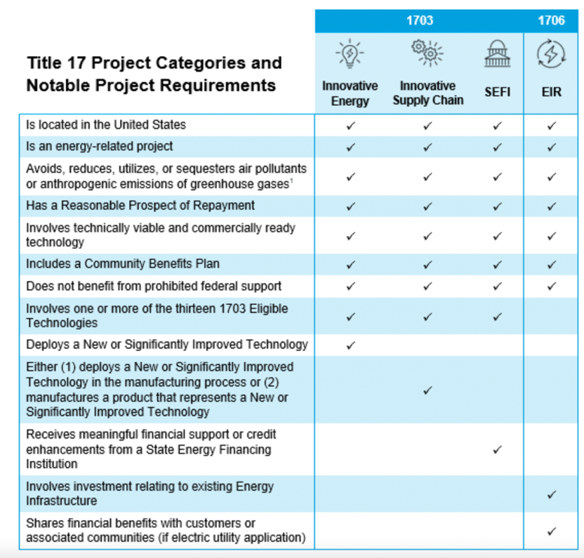
Source: DOE

Appendix C: 1982 Users Guide to Government Energy Programs
Cover, Preface, and Table of Contents

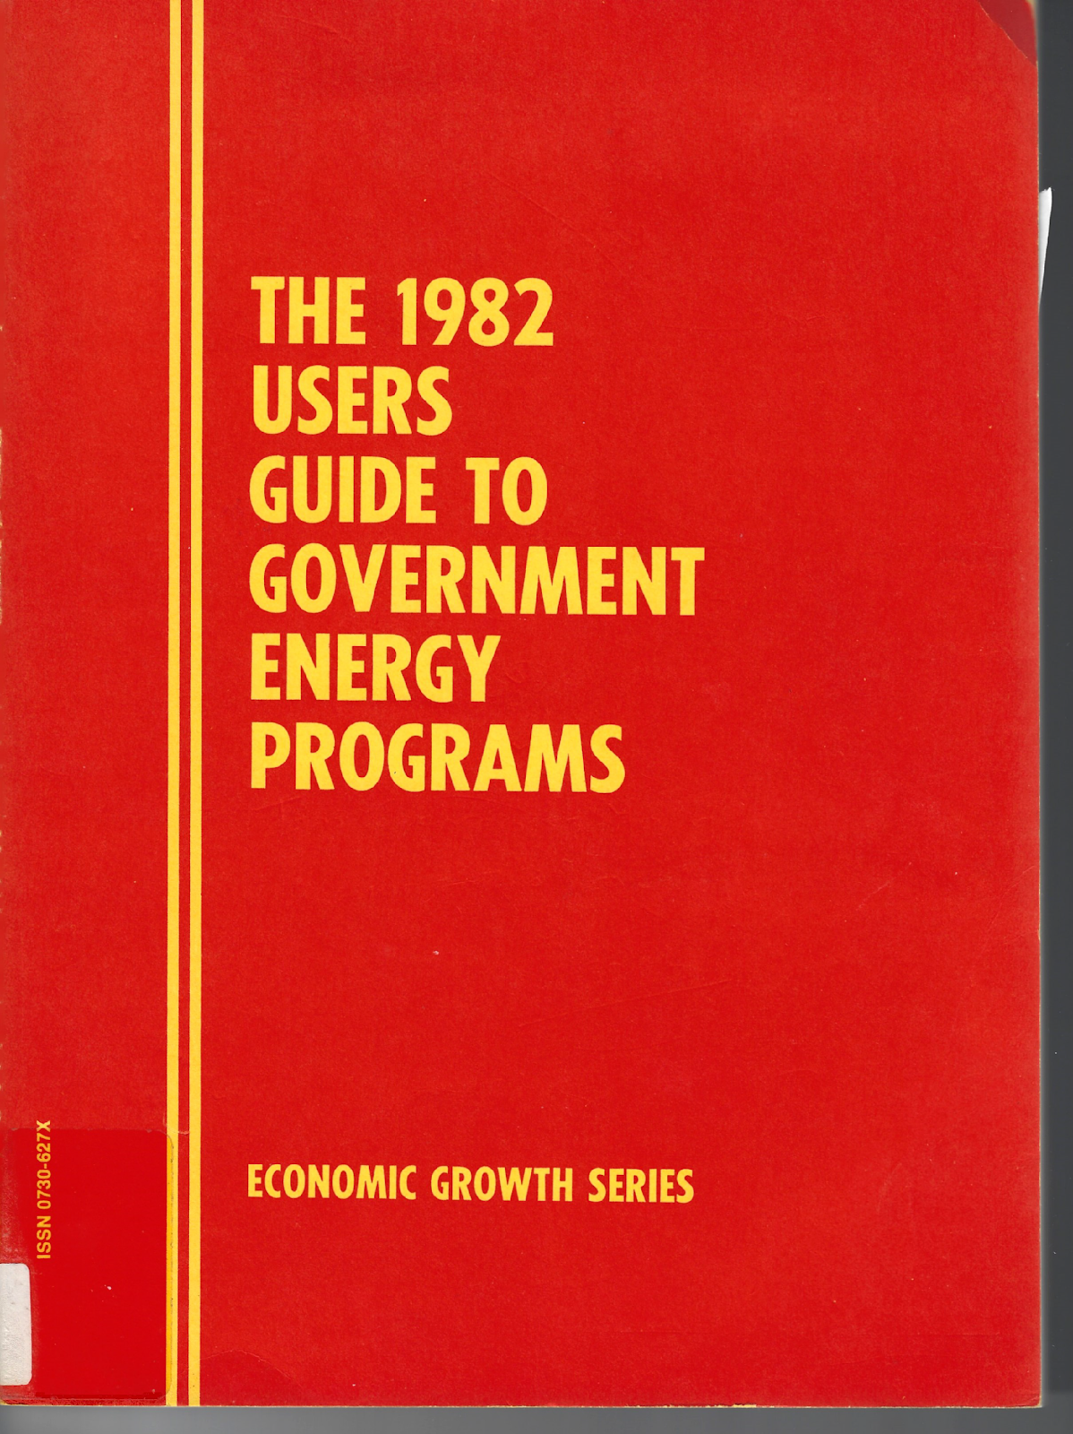

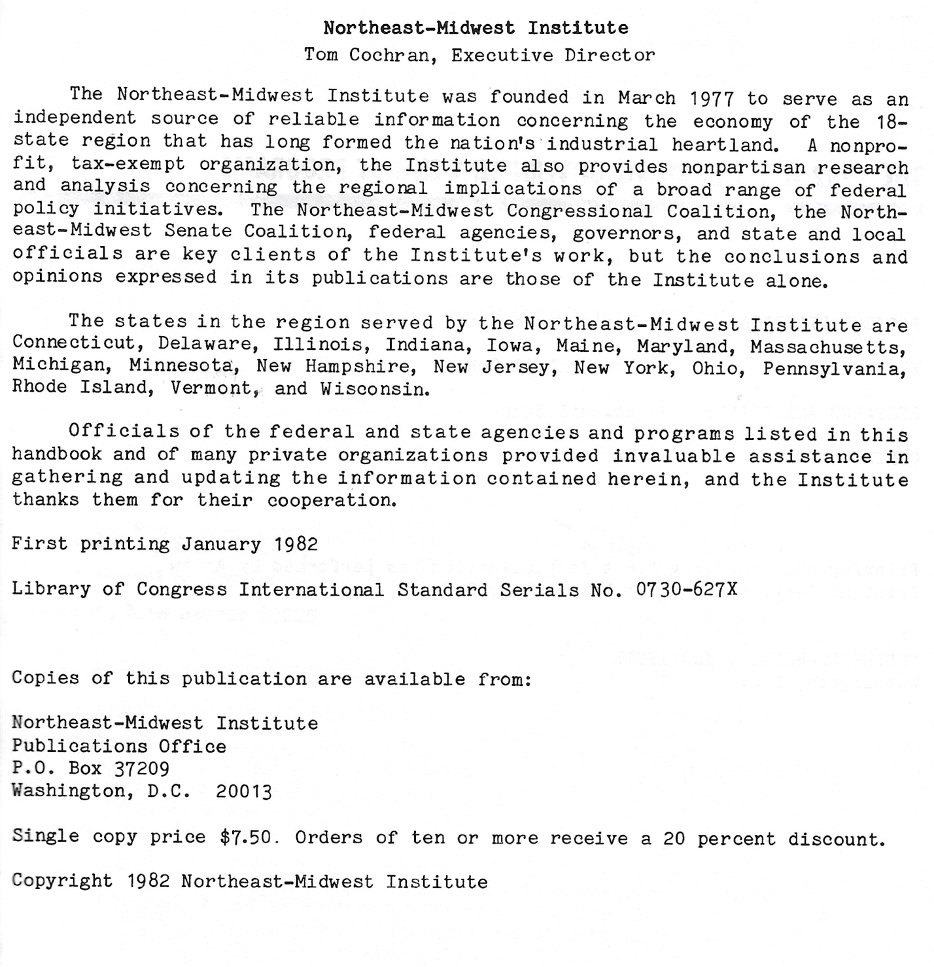

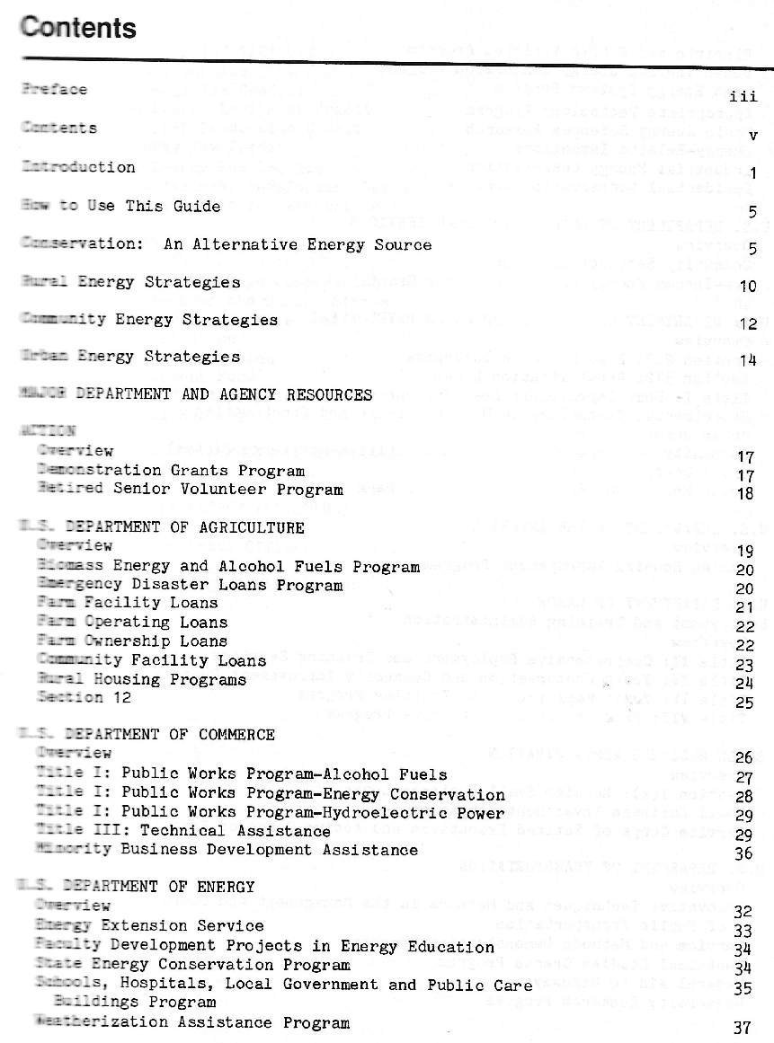
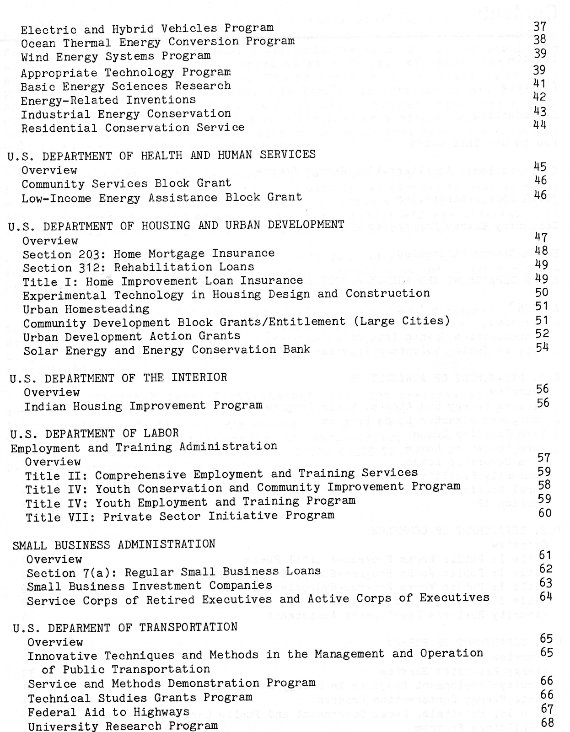

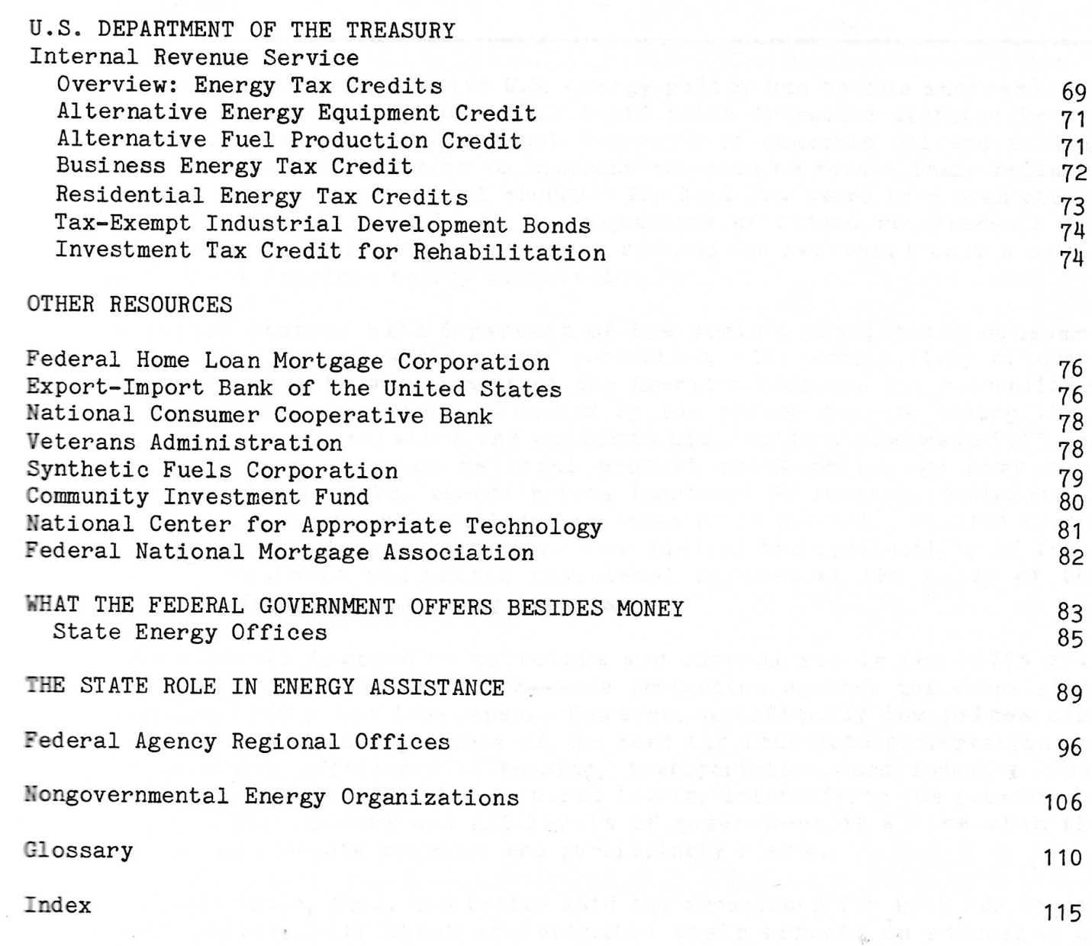

Appendix D: Regulatory Context in the Northeast (1) and Midwest (2)

(1)

The Northeastern states of Connecticut, Maine, Massachusetts, New Hampshire, New Jersey, New York, Rhode Island, and Vermont have a long history of setting aggressive climate goals relative to other US states and acting in collaboration to achieve emissions reductions and greater energy security in the region. Various government-led programs, including the Regional Greenhouse Gas Initiative (RGGI) and New England States Committee on Electricity (NESCOE), are demonstrations of Northeastern states’ willingness to cooperate to meet their respective energy goals. These efforts continue to gain momentum; recently, states in the Northeast have sought federal aid for potentially transformational transmission and clean hydrogen projects.

The six New England states, alongside New York and New Jersey, are now asking DOE to provide funding and technical support for the integration of the region’s three functioning Regional Transmission Operators (RTOs). This is a concrete step towards achieving the goals set forth in the vision statement published by NESCOE in 2020. Addressing grid integration and modernization will be key in the region and all across the country for meeting decarbonization goals by enabling new renewable energy generation projects, especially offshore wind, to connect to the grid and get to end-users.

In addition, the recently formed Northeast Regional Clean Hydrogen Hub submitted a $3.62 billion investment proposal to the DOE for implementing clean hydrogen programs in industries that are difficult to decarbonize, such as transportation and heavy industry. If approved, the states will receive $1.25 billion of the $8 billion dollars made available in the IIJA for federally designated clean hydrogen hubs.

The region’s current power grid profile is notably dominated by natural gas and nuclear power, while coal and oil collectively provide less than 2% of the region’s electricity generation. As we look to the future, proposed generation projects are primarily offshore wind, battery storage, and solar production units. According to ISO New England, as of January 2023, developers had proposed 32,000MW of new generation capacity with 50% coming from wind, 35% from battery storage, and 12% from solar. In order for those projects to materialize, they will have to overcome regulatory and political barriers despite the generally favorable view of renewable energy and existing support for a clean energy transition in the region.

Project developers in the Northeast often come up against NIMBYism; local opposition to renewable energy and transmission projects has delayed and even shut down many of them. This should not come as a surprise, seeing as the region encompasses the seven most densely populated states in the country, and is home to numerous urban hubs located far away from the large, renewable electricity generation centers that have the capacity to power them. For instance, a project called Northern Pass Transmission Line, which would have delivered 1,090MW of electricity, mostly produced by hydroelectric dams, from Quebec to the New England power grid, was shut down after the New Hampshire Site Evaluation Committee rejected its permit application in 2018, siting a potential negative impact on local tourism and business. In July 2019 the rejection was upheld by the New Hampshire Supreme Court and developers had to give up on the project. In Maine, a similar project named the New England Clean Energy Connect Transmission Line was forced to halt construction in 2021 after 59% of Maine residents voted against the project’s completion in a state-level referendum. The decision was recently overturned in court, but developers lost time and money throughout the years-long hiatus.

New language in the IIJA regarding FERC’s authority over approval of transmission lines in areas designated “national interest electric transmission corridors” by DOE will hopefully address some of these issues and speed up approval processes. As for other local and state level barriers that solar and wind projects often encounter, developers must proactively meet requirements and engage with local community members in order to avoid complications and controversies. The Council on Environmental Quality aggregated memoranda on individual states’ environmental review planning requirements, comparing them each to federal NEPA provisions. Additionally, EPA has suggestions for states about implementing policies that incentivize development of new clean energy capacity and reduce barriers. Under the current federal administration, these states are well poised to make significant advances in clean energy development and should continue to take advantage of the resources made available to state and local governments under the IRA and IIJA.

However, efforts to cooperate do not always deliver, as demonstrated by the abandonment of the Transportation Climate Initiative (TCI). A cap-and-trade scheme devised to reduce transportation emissions and bring in dollars to fund other climate initiatives, the plan fell through in 2021 when only a handful of states actually signed onto the program after years of work went into drafting it. Furthermore, the impending closure of the Coalition of Northeastern Governors (CONEG) speaks to the need for proactive efforts from representatives of member states to maintain institutions that serve as shared points of contact.

(2)

The Midwest has historically been a region particularly reliant on coal plants, which powered the heavy machinery used in their manufacturing and agricultural sectors. This remains true relative to other regions in the US despite rapid gains in renewable energy generation capacity over the last decade. The region encompasses some of the most intensely coal-consuming states in the country, with five Midwestern states in the top ten list from 2019. However, in response to more aggressive Renewable Portfolio Standards (RPS) and falling prices, utilities and project developers continue to terminate coal-fired plants and replace them with natural gas (50% fewer emissions) and renewable generation operations (100% fewer emissions). Utilities across the region are in different stages of phasing out coal plants.

As this necessary transition is made, there will be a need to support the communities in which coal plants serve as the backbone of the local economy. Since 2016, 55 have closed and 33% of the remaining 81 had announced planned terminations. In recognition of this, Midwestern states are increasingly demonstrating an interest in collaborating on energy and community projects to fulfill their clean energy goals. Partnering with the Just Transition Fund, Minnesota Governor Tim Walz used his post as chairman of the Midwestern Governors Association (MGA) to bring stakeholders together and ultimately produce a report with policy recommendations to Midwestern states for supporting coal plant communities to ensure a just clean energy transition.

Beyond providing aid for those communities and individuals most impacted by this transition, MGA has also begun a process to upgrade their transmission system so that it will be able to incorporate and deliver electricity from new renewable energy generators. Over the last couple of years, MGA has focused on bringing together stakeholders in the region to discuss the state of long-range transmission and grid interconnectivity. This vision statement for the program, named Mid-Grid 2035, expresses the need for the three RTOs serving the region, MISO, SPP, and PJM Interconnection, to engage in both short and long-term regional planning that delivers access to competitive energy rates and clean generation for customers. The coalition meets to discuss on a quarterly basis.

With renewables now cheaper than coal, and more aggressive Renewable Portfolio Standards in many Midwestern states, renewable projects, wind in particular, have become quite prevalent across the region. The number of clean energy jobs in the Midwest reached 160,000 in 2017, mostly concentrated in rural areas. These communities stand to benefit economically from renewable projects through increases to the tax base, attracting new infrastructure investments, and royalty payments for those who host wind turbines and solar panels on their lands. Additionally, a Harvard study found that wind turbines are most effective in the Midwest when compared to other locations; 1 megawatt hour of wind energy in the Midwest is worth $113, compared to $28 in California.

As in most places, siting is often a challenge due to local opposition, particularly where tourism is a concern. Economic stimulus for energy communities is persuasive to some, but not all. Improving reception through messaging and outreach by highlighting the concrete, economic benefits for communities is a must. The Renewable Energy Siting Campaign, a new initiative underway in Illinois, partners with communities to determine opportunities through intentional project development design.

In addition to transitioning away from coal to renewable energy, there is also a need to make transportation, the highest emitting sector in the US, more reliant on electricity generation. Reducing tailpipe emissions, which have surpassed coal plants as the most significant source of carbon emissions in many states, is critical. While coal is getting some much needed attention, an increase in car commutes - partially a result of frequent use of newer services like Amazon and Uber - is causing transportation emissions to climb. Thus far, only three Midwestern states, Illinois, Michigan, and Minnesota, have passed Clean Transportation Standards legislation. Hopefully others will soon follow, as has often been the pattern for the passage of clean energy legislation in the region.

Previous attempts to strengthen clean energy policies in bold fashion have demonstrated the importance of a good economic climate for renewables and some sense of urgency among constituents and representatives to pass that legislation. Those two conditions fell short in 2007 as several Midwestern governments attempted to adopt the Midwestern Greenhouse Gas Accord, which has been inactive since 2010. Now, in the context of historic federal legislation like the IRA and IIJA, many agree that there is a window of opportunity for the Midwest to reap economic and environmental benefits alike through a continued push for renewable energy, energy efficiency, and electrification.

Appendix E: New England States’ Green Banks and Climate Action Plans

State | Green Bank | State Action Plan / Last Updated
Connecticut | Yes | Yes | 2021
Maine | Yes | Yes | 2020
Massachusetts | Yes | Yes | 2022
New Hampshire | No | Yes | 2009
Rhode Island | Yes | Yes | 2016
Vermont | No | Yes | 2021

Connecticut

Green Bank | State Action Plan
Connecticut Green Bank  2022 Annual Report  - Established July 2011  - Quasi-public state entity  - Received $186 million in state financing  - Leveraged $755 million of private investments  - Focus investments on renewable energy and energy efficiency | Climate Action Plan: Taking Action on Climate Change and Building a More Resilient Connecticut for All  Released 2021  Mandate: Governor Lamont’s Executive Order No. 3 (2019) expanded the mandate of the Governor’s Council on Climate Change (GC3) to include monitoring, reporting on, and providing recommendations for a state-wide approach to climate adaptation and resilience while placing a central focus on equity and environmental justice.  Emissions Targets: The plan must help the state achieve its goal to reduce GHG emissions by 45% below 2001 levels by 2030 and 80% by 2050, and to attain a zero-carbon electricity sector by 2040.  Contributors: 23 GC3 members, 231 individual members, and 100 contributing organizations met over many months in seven working groups to produce this plan.  By Sector: The report produces near-term action recommendations for mitigation strategies within the following sectors: buildings, electricity, non-energy, transportation, working and natural lands, infrastructure, public health, financing & funding adaptation & resilience, and science & technology.

Maine

Green Bank | State Action Plan
Efficiency Maine Trust  2022 Annual Report  - Established 2009  - Invests in high efficiency operations and equipment  - Independent, quasi-public state entity  - Oversight from the Public Utilities Commission | Maine Won’t Wait  2-Year Progress Report  Released Dec. 2020  Mandate: With the passage of LD 1679 in June 2019, the Maine Climate Council was created with the charge of creating a 4-year climate action plan that will set Maine on track to meet its emission reduction targets.  Emissions Reductions: Targets are set at 45% below 2001 levels by 2030 and 80% by 2050, as well as achieving carbon neutrality by 2045.  Contributors: The Council -- an assembly of scientists, state officials, industry leaders, and citizens – convened with other members of six working groups totaling over 200 individuals to create this document.  By Sector: The report features strategies to address the climate impact of the transportation, buildings, industrial, clean energy, natural resources, and environment and working lands and waters sectors while building resilient communities.

Massachusetts

Green Bank | State Action Plan
Community Climate Bank  - Announced June 13, 2023  - Investments in affordable, decarbonized housing  - Located within MassHousing, the state’s Housing Finance Agency  - Explicitly created to attract federal IRA investments and tackling environmental justice issues in the housing sector  - $50 million in initial funds provided by the Department of Environmental Protection | Clean Energy and Climate Plan for 2025 and 2030  Released June 2022  Mandate: In 2021, An Act Creating a Next-Generation Roadmap for Massachusetts Climate Policy was signed into law with a mandate to create a comprehensive plan to accompany the establishment of emissions reductions targets set forth by the Secretary of Energy and Environmental Affairs.  Emissions targets: The Act led to the establishment of reductions targets set at 33% and 50% by 2025 and 2030 respectively, and a net-zero economy by 2050.  Contributors: Members of the Global Warming Solutions Act Advisory committee and its working groups, the Zero-emission Vehicle Commission, the Clean Heat Commission, technical advisors to the Natural and Working Lands GHG emissions accounting, and members of the public were all important voices.  By Sector: The plan creates a set of strategies aimed at reducing emissions in the transportation, buildings, electricity generation, and industrial sectors while increasing carbon sequestration on working lands and incorporating core environmental justice principles.

New Hampshire

Green Bank | State Action Plan
None | NH Climate Action Plan  Released March 2009  Mandate: Governor John Lynch created the Climate Change Policy Task Force through gubernatorial executive power with the purpose of creating a plan to achieve emissions reductions while delivering long-term benefits to residents of the state.  Emissions Reductions: None were in place at the time of this study’s undertaking, and there still exists no legislatively mandated targets. One of the findings of this study was to recommend emissions reductions of 20% below 1990 levels by 2025 and 80% by 80% by 2050.  Contributors: 29 members coming from various agencies and public sector backgrounds within the state.  By Sector: The plans focuses on possible actions that could be taken in the buildings, electricity, and transportation sectors, primarily through maximizing energy efficiency and expanding reliance on renewable energy, as well as the preservation of natural resources to promote carbon sequestration.

Rhode Island

Green Bank | State Action Plan
Rhode Island Infrastructure Bank  2022 Annual Report  - Quasi-public entity  - Investments in clean energy, water, and transportation sectors  - Mandate expanded to qualify as a green bank in 2015 | GHG Emissions Reduction Plan  Released Dec 2016  Mandate:  This plan was created by the Executive Climate Change Coordinating Council (EC4) as legislatively mandated by the Resilient Rhode Island Act in 2014. The plan’s purpose is to make recommendations that will enable the state to meet its emissions reductions targets.  Emissions Reductions: The emissions targets set forth in the Act were recently updated in the 2021 Act on Climate to 45% below 1990 levels by 2030, 80% by 2040, and net-zero by 2050.  Contributors: The Project Team overseeing this study included staff from the state’s Department of Environmental Management, Office of Energy Resources, Department of Transportation, Division of Planning, and a technical committee comprised of various climate and energy stakeholders.  By Sector: The report makes recommendations about how the state can achieve deep mitigation through focusing on energy efficiency, electrification, decarbonization of electricity, and decarbonization of other fuels through the buildings, transportation, and electricity sectors.

Vermont

Green Bank | State Action Plan
None | Initial Vermont Climate Action Plan  Published December 2021  Vermont  Mandate: The Global Warming Solutions Act (2020) created the Vermont Climate Council for the purpose of creating a plan to achieve emissions reductions and build community resilience in the state.  Reductions Targets: According to the Global Warming Solutions Act, Vermont must achieve reductions of no less than 26% below 2005 GHG emission levels by January 1, 2025; by no less than 40% below 1990 GHG emission levels by January 1, 2030; and no less than 80% below 1990 GHG emission levels by January 1, 2050.  Contributors: 23-member council, including 8 administration officials and 15 legislature appointments representing different sectors placed into 5 subcommittees: Rural Resilience and Adaptation, Cross-sector Mitigation, Just Transition, Agriculture and Ecosystems, and Science and Data.  The plan focuses on transportation, buildings, electricity, agriculture, and other non-energy emissions including industrial waste as pathways to emissions reductions while specifying mechanisms by which to prioritize environmental justice and workforce development.

Areas: clean energy, transportation, housing, transmission, infrastructure/materials, air quality,
conservation, and social equity.

The Northeast-Midwest Institute primarily focuses its research on states in the Northeast and industrial Midwest regions, including Connecticut, Delaware, Illinois, Indiana, Iowa, Maine, Maryland, Massachusetts, Michigan, Minnesota, New Hampshire, New Jersey, New York, Ohio, Pennsylvania, Rhode Island, Vermont, and Wisconsin.
The SRF program was enacted by Congress during the Reagan years, to replace grant programs which had previously supported the construction of large-scale sewerage treatment and potable water projects and that had been eliminated as a fiscal austerity measure.
Phone interview with Robert Lamb, President, Lamont Financial Services Corporation 8/26/23.
For more information, please consult the full Request for Applications (RFA) document.
Non-profit entities which have publicly announced online their intent to apply for a NCIF and/or other GGRF grants include: The Coalition for Green Capital (CGC) dba American Greenbank Coalition; Climate United, a partnership of Calvert Impact, Community Preservation Corporation and Self-Help; and The Justice Climate Fund.
For more information, please consult the RFA.
For more information, please consult the RFA.
Fiscal Federalism: Theory and Practice , Congressional Research Service, 20 June 2023, crsreports.congress.gov/product/pdf/R/R46382.
“What Is a Green Bank.” Coalition for Green Capital, 8 May 2020, coalitionforgreencapital.com/what-is-a-green-bank/.
Time did not permit the research necessary to cover all eighteen states in the region.
Phone interview with Robert Lamb 9/23/2023
Author notes from in-person attendance.

