**CONSERVATION IMPACT**

**IN THE VERMILION, ILLINOIS WATERSHED**

**Impacts of land management and climate change scenarios**

**in the HUC-12- 07130002 watershed in Vermilion, Illinois**

**Key Findings**

* Conservation tillage with crop cover (of rye grass during none cultivation season) was effective in reducing soil erosion and keeping soil nutrients in the fields in the HUC-12- 07130002 watershed in Vermilion, Illinois, both in the historic climate and plausible climate change conditions; conservation tillage with crop cover may reduce soil erosion by ~18-24%, total nitrogen loss by 17-25%, and total phosphorus loss by 15-18% for the historic and future climate change conditions.
* In HUC-12- 07130002 watershed, farmers’ current tillage practice (so called baseline tillage) plus harvesting the biomass from the fields was found effective in reducing pollution coming from total nitrogen loss. Over the long-term, the baseline tillage with biomass harvested may reduce the average annual total nitrogen loss from the watershed by 16-31% compared to baseline tillage.
* The impact of climate change on water resources availability over the coming three decades (2021-2050) in the HUC-12- 07130002 watershed was minor according to the climate change data from the Hadley model 4.5 and 8.5 representative concentration pathways (RCPs) scenarios. This was because of smaller changes in projected rainfall in the watershed.
* The findings suggest that policy options that promote conservation tillage with cover crop may help to enhance agricultural productivity in upstream areas and reduce pollution in downstream freshwater systems.

**Introduction**

The objective of this project is to estimate the impact of different land management practices and climate change on water quantity and quality in the HUC-12- 07130002 watershed. The analysis was conducted using the Hydrologic and Water Quality System (HAWQS) framework, which uses the Soil and Water Assessment Tool (SWAT) as its core modeling engine (HAWQS, 2019). SWAT is a physically-based model developed to predict the impact of land management practices on water, sediment, and nutrients in watersheds having different soils, land use and management conditions (Arnold et al., 1998; Srinivasan et al., 2010). HAWQS uses hydrologic unit codes (HUCS) to run simulations.

**About the watershed**

The HUC-12- 07130002 watershed is located in Vermilion in Illinois (Figure 1). The watershed has a catchment area of 3,453 km2. About 43% the watershed was cultivated with corn and 42% was cultivated with soybean (Table 1). The HUC SWAT model setup provided 40 sub-basins and 786 Hydrological Response Units (HRUs). HRUs are the smallest units in the SWAT model which has unique combinations of land use, soil, and slope class. The model was simulated for the historical time period of 1989 to 2018. The agricultural fields in the watershed have four forms of cropping pattern (i.e. some of the fields were dedicated to individual corn and soybean crop cultivations while some fields were used for crop rotations between corn and soybean) (Table 1).

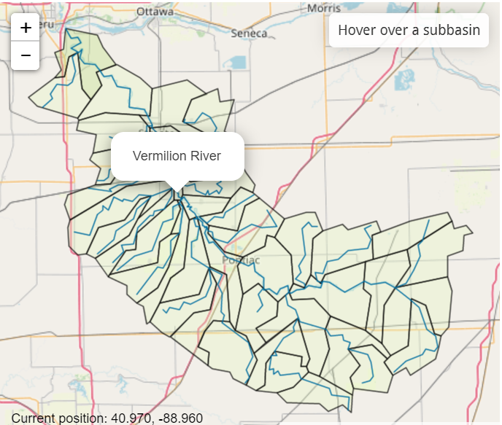

Figure 1. Location of the HUC-12- 07130002 in Vermilion, Illinois.

Table 1. Proportion of the watershed dedicated to corn and soybean fields.

|  |  |
| --- | --- |
| Cropping field | Percent of watershed |
| Corn | 12 |
| Corn/soybean rotation | 31 |
| Soybean | ~3 |
| Soybean/corn rotation | 39 |

**Studied scenarios**

The study analyzed four land management and two climate change scenarios from the Hadley General Circulation Model (GCM). The land management scenarios considered were the current farmers practice tillage (hereafter called baseline tillage) and other three different tillage practices (Table 2). One of the tillage builds on the baseline tillage and allows removal of biomass from corn and soybean fields, which is practiced by some farmers. The other two tillage scenarios are conservation tillage and conservation tillage with cover crop using rye grass. Conservation tillage is an agricultural practice that reduces soil disturbance and enhances soil crop residue on the soil surface. The fourth scenario considers conservation tillage plus cover crop with rye grass in periods where there was not crop production. Use of cover crop like rye grass is recommended to reduce soil erosion and nutrient loss from the soil.

Table 2. Studied land management scenarios in different fields in the HUC-12- 07130002 watershed.

|  |  |  |  |  |
| --- | --- | --- | --- | --- |
| **Scenarios** | **Corn fields** | **Corn/ Soybean rotation fields** | **Soybean fields** | **Soybean/Corn rotation** |
| Baseline tillage (current farmers’ practice) | No till (<1% of the watershed); reduced tillage (~10% of watershed); conservation tillage (~1%) | No till (<1% of watershed); reduced tillage (29%); conservation tillage (~1%) | No till (<1% of watershed); reduced tillage (<1%); conservation tillage (<1%) | No till (10.6% of watershed); reduced tillage (21%); conservation tillage (~7.4%) |
|  |  |  |  |  |
| Baseline tillage with residue removed | Baseline tillage with biomass harvested | Baseline tillage with biomass harvested | Baseline tillage with biomass harvested | Baseline tillage with biomass harvested |
|  |
| Conservation tillage | Generic conservation tillage | Generic conservation tillage | Generic conservation tillage | Generic conservation tillage |
| Conservation tillage with cover crop | Generic conservation till with cover crop of rye grass | Generic conservation till with cover crop of rye grass | Generic conservation till with cover crop of rye grass | Generic conservation till with cover crop of rye grass |

The climate change scenarios were based on the Hadley Centre HadCM2 model climate change outputs for the 4.5 and 8.5 Representative Concentration Pathways (RCPs). Based on the scenario definition of the Intergovernmental Panel on Climate Change (IPCC), RCP 4.5 is described as an intermediate change scenario while RCP 8.5 is generally considered as the basis for worst-case climate change scenario. The climate change analysis was conducted for 30 year time periods based on recommendation from the World Meteorological Organization (WMO, 2017). The historical climate spans for the period 1989 to 2018 and the climate change was studied for the near-term future of 2021-2050. The analysis of the climate data based on Hadley model for the 4.5 and 8.5 RCPs showed that both precipitation and temperature may increase in the coming three decades (Figure 2). The increase in precipitation may not be substantial. 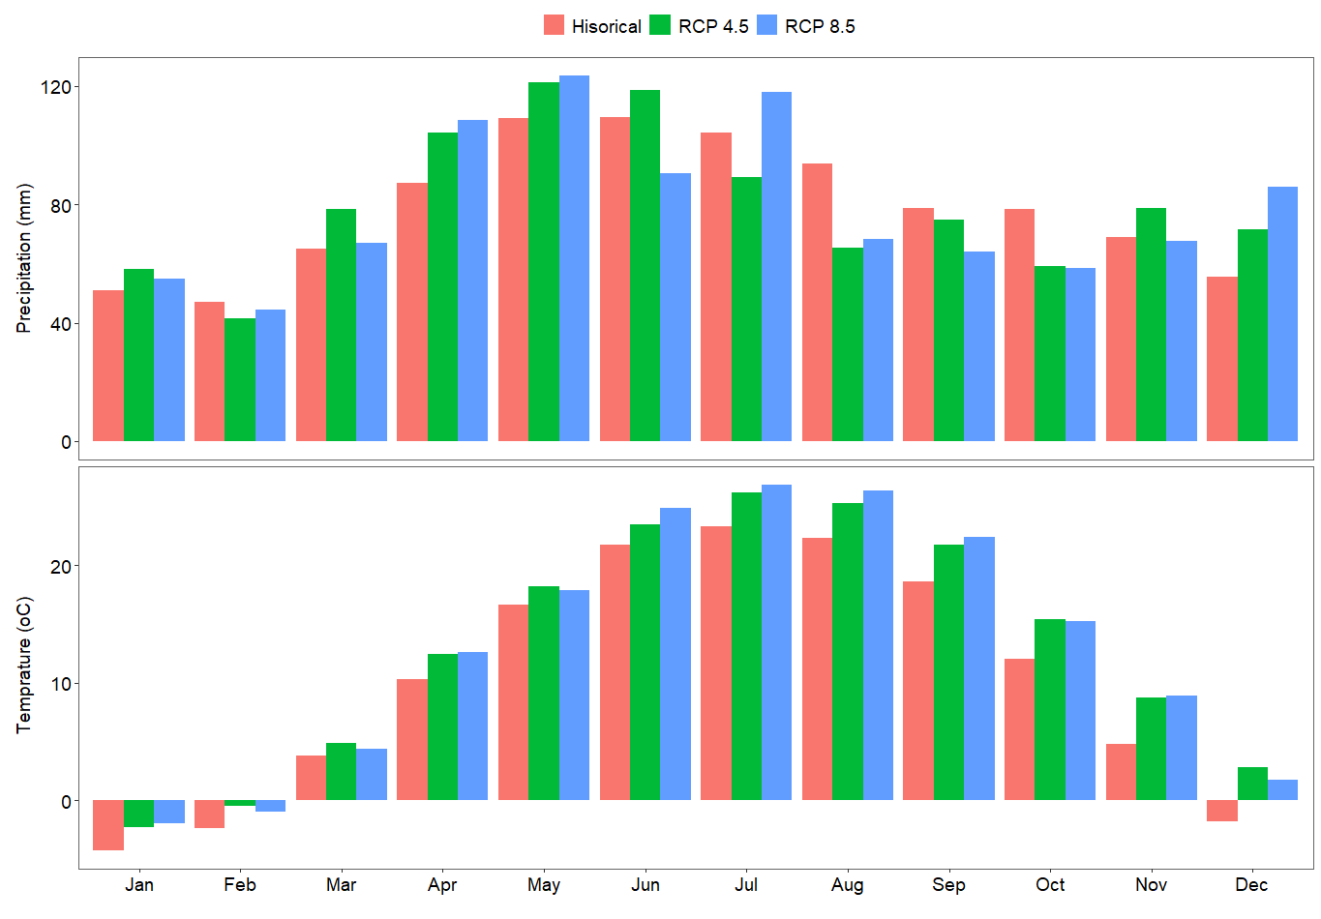

Figure 2. Long-term average monthly precipitation (mm) and temperature (oC) are for the historical (1989-2018) and near-term future (2021-2050) climate conditions. The climate change projection was based on the Hadley model 4.5 and 8.5 representative concentration pathways (RCP) scenarios. Baseline tillage is current farmers’ practice.

**Impacts of land management** s**cenarios with historic climate**

The impact analysis showed that conservation tillage practices substantially reduce soil erosion and nutrient leakage into the freshwater systems (Figure 3). For example, conservation tillage with crop cover caused the highest reduction in sediment yield at the watershed outlet. Analysis over the long-term climate (1989-2018) showed that conservation tillage with crop cover may reduce the average long-term annual sediment yield by 23% as compared to the baseline tillage. The highest reduction in total nitrogen loss from the watershed was observed with the baseline tillage with biomass harvested followed by baseline tillage with crop cover. Over the long-term, the baseline tillage with biomass harvested and conservation tillage with crop cover caused 27% and 23% reduction on the average annual total nitrogen loss from the watershed compared to baseline tillage, respectively. The conservation tillage without crop cover scenario caused only 2.5% reduction in the long-term average annual total nitrogen loss compared to baseline tillage. The highest reduction in the nitrogen loss in the baseline tillage with biomass harvested scenario was related to the removal of nitrogen with the biomass. Similarly, conservation tillage with crop cover caused the highest reduction in total phosphorous loss at the watershed outlet. Compared to the baseline tillage, the conservation tillage with crop cover caused a 15% reduction of the long-term average annual total phosphorus loss from the watershed. However, the conservation tillage without any crop cover increased the long-term average annual total phosphorus loss at the watershed outlet by ~3% compared to the baseline tillage, while the baseline tillage with biomass harvested caused a marginal (<1%) reduction on the long-term phosphorus loss.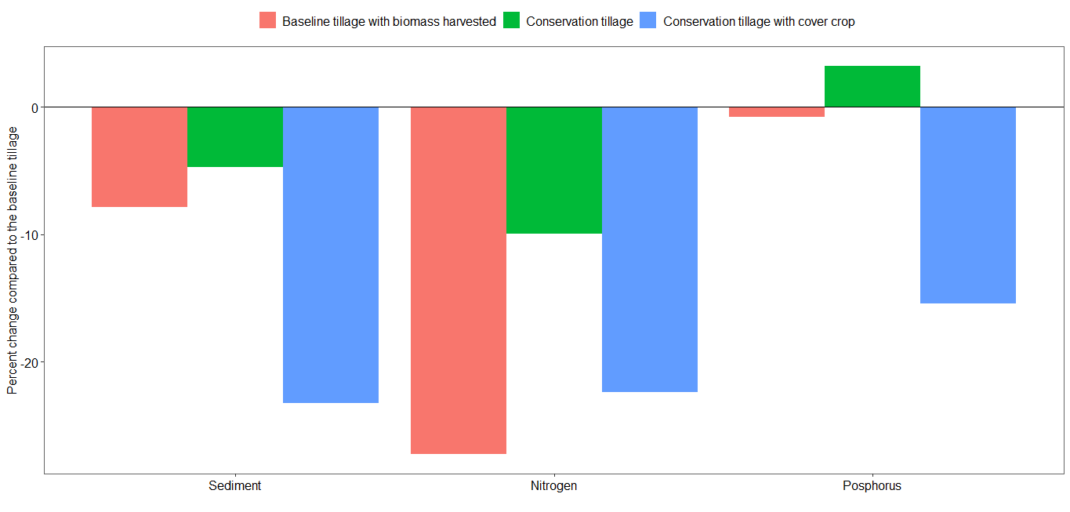

Figure 3. Percent change on long-term average annual sediment yield, total nitrogen, and total phosphorous loss at the watershed outlet for the baseline tillage with biomass harvested, conservation tillage, and conservation tillage with cover crop in the historic climate (1989-2018) compared to the baseline tillage.

**Climate change scenarios on water quantity**

Climate change impact assessment using the Hadly model climate data for the 4.5 and 8.5 RCP showed that climate change may not significantly affect the water resources availability in the HUC-12- 0713002 watershed (Figure 4). The ratio of long-term streamflow to precipitation ratio over the watershed was 30% in the historical climate condition (1989-2018) and it was 26% for both 4.5 and 8.5 RCP scenarios. There was minor difference in the projectd rainfall of the 4.5 and 8.5 RCPs in the coming three decades. The long-term evapotranspiration to precipitation ratio over the watershed in the historical climate was 65%, and it was 70% in both the 4.5 and 8.5 RCPs. Timeseries analysis also showed that the change in streamflow at the watershed outlet was minor due to the impact of climate change (Figure 5). The long-term average daily streamflow for the historical time period was ~34 m3/sec, while for the 4.5 and 8.5 RCP, it was 30.2 m3/s and 29.8 m3/s, respectively, for the near-term future of 2021-2050, respectively.

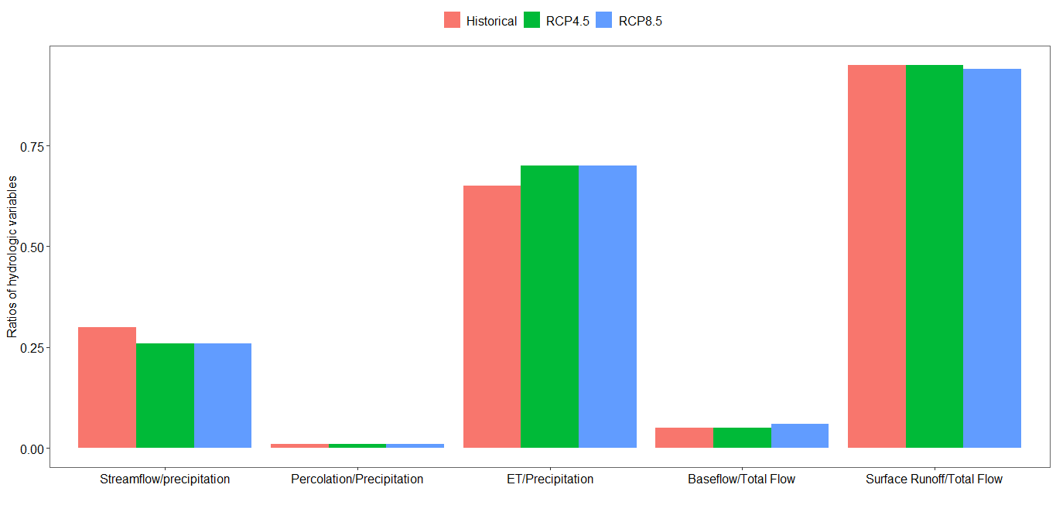

Figure 4. Water resources partitioning into different components in the watershed based on simulations using long-term historical climate (1989-2018) and future (2021-2050) climate change data for the 4.5 and 8.5 representative concentration pathway (RCP) for the Hadley model.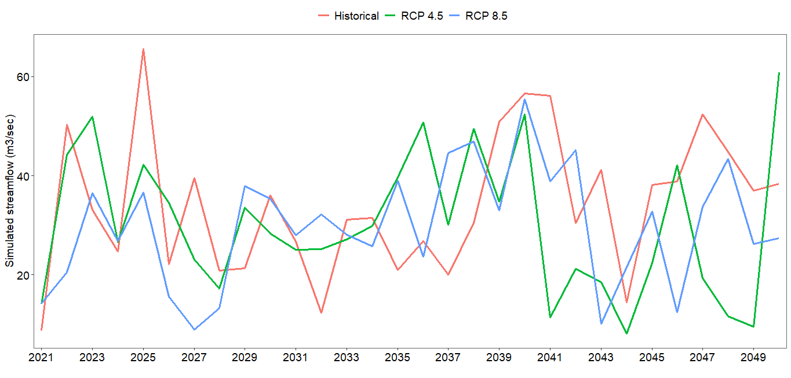

Figure 5. Simulated annual streamflow at the watershed outlet using historical climate (1989-2018) and projected climate using 4.5 and 8.5 representative concentration pathways (RCPs) of the Hadley model for the near-term future (2021-2050).

**Management scenarios simulated with climate change scenarios**

The conservation tillage with crop cover was found the best tillage practice to reduce soil erosion and nutrient leakage from the watershed in the plausible climate change condition (Figure 6). For example, conservation tillage with crop cover reduced the long-term average annual (2021-2050) sediment yield from the watershed by ~24% in the plausible climate change scenario of the Hadley model 4.5 RCP compared to continuing the baseline tillage for the same climate change condition. The conservation tillage with crop cover reduced the long-term average annual total nitrogen loss at the watershed outlet by ~25% compared to continuing the baseline tillage in the plausible climate change scenario of 4.5 RCP. In fact, the reduction with the average annual total nitrogen loss was higher (31%) with the scenario of baseline tillage with biomass removed. The baseline tillage with biomass harvested provided the highest reduction in the long-term average annual total nitrogen loss due to removal of nitrogen with the biomass. The conservation tillage with crop cover may reduce the long-term average annual total phosphorus loss by ~18% compared to the baseline tillage in the 4.5 RCP climate change scenario. The baseline tillage with biomass harvested may reduce the long-term total average annual phosphorus loss by 4% compared to the baseline scenario for the 4.5 RCP climate change scenario. However, implementing conservation tillage without crop cover may increase the average annual total nitrogen loss from the watershed by 3% compared to continuing the baseline tillage in the plausible climate change scenario of 4.5 RCP in the Hadley model.

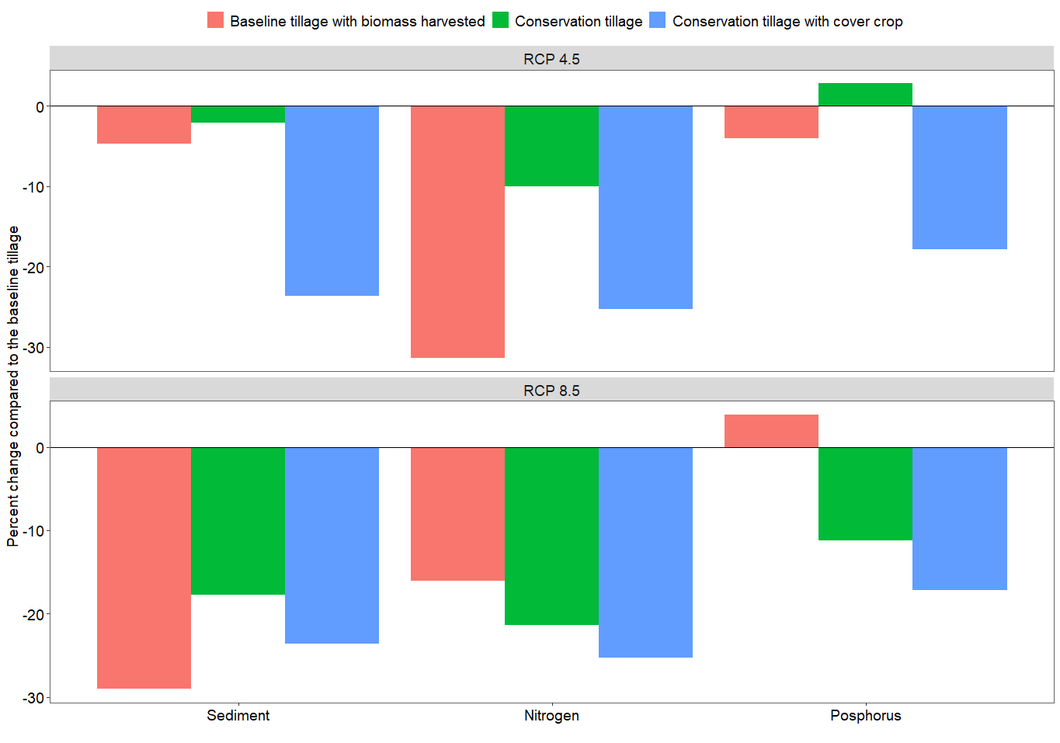

Figure 6. Percent change on long-term average annual sediment yield, total nitrogen and total phosphorus losses at the watershed outlet for the baseline tillage with biomass harvested, conservation tillage, and conservation tillage with crop cover compared to continuing the baseline tillage for a plausible climate change scenario of 4.5 and 8.5 RCPs of the Hadley model.

In the 8.5 RCP scenario, the baseline tillage with biomass harvested provided the highest total average annual sediment yield reduction (29%) followed by conservation tillage with crop cover compared to continuing the baseline tillage in the plausible climate change scenario of the 4.5 RCP of the Hadley model (Figure 6). Conservation tillage reduced the total average annual total sediment yield by 18% compared to continuing the baseline tillage in the 8.5 RCP climate change scenario in the near-term future of 2021-2050. The conservation tillage with crop cover caused the highest reduction in total nitrogen and phosphorus losses with the simulations using the RCP 8.5 climate change scenario of the Hadley model (Figure 6). The conservation tillage with crop cover and conservation tillage without crop cover reduced the long-term average annual total nitrogen loss by ~25%, and 21% compared to continuing the baseline tillage for a plausible climate change scenarios of 8.5 RCP of the Hadley model, respectively. The baseline tillage with biomass harvested reduced the long-term average annual total nitrogen loss by 16% as compared to the baseline tillage when simulated with the 8.5 RCP climate change scenario. The conservation tillage with crop cover and conservation tillage without crop cover reduced the long-term average annual total phosphorus loss by ~17%, and ~11% compared to continuing the baseline tillage for a plausible climate change scenario of 8.5 RCP of the Hadley model, respectively. However, the baseline tillage with biomass harvested increased the long-term average annual total phosphorus loss by ~4%.

**Policy Recommendations**

Watershed analysis of the HUC-12-07130002 watershed in Vermilion, Illinois documents the effectiveness of conservation practices both currently and in the face of future climate change. Conservation tillage with crop cover of rye grass was the most effective in reducing soil erosion and nutrient leakage from the HUC-12-07130002 watershed both for the historic climate and climate change conditions. Farmers’ current practice, so called baseline tillage, plus harvesting the biomass, was also found effective in reducing total nitrogen leakage from the watershed, especially in the historic climate and 4.5 representative concentration pathway (RCP) climate change condition. However, the conservation tillage with crop cover was consistent in reducing different pollution types (i.e. soil erosion, total nitrogen and total phosphorus), and different climatic conditions. Conservation tillage with crop cover by reducing soil erosion and maintaining nutrients within the soil can enhance agricultural productivity within the fields, and also reduce pollution of freshwater systems downstream.

Major policy recommendations therefore include:

* Funding for continued and increased conservation programs is essential, and even more so in the face of projected future climate change.
* Policy-makers should consider developing policy options that promote conservation tillage with cover crop to improve agricultural and ecosystem productivity in upstream areas, and also reduce pollution of downstream freshwater systems.

**References**

Arnold, J.G., Srinivasan, R., Muttiah, R.S., Williams, J.R., 1998. Large area hydrologic modeling and assessment part I: model development. Journal of American Water Resources Association 34, 73–89.

HAWQS, 2019. HAWQS User Guide Prepared by the Spatial Sciences Laboratory Texas A&M AgriLife Research College Station, TX For the Office of Water, Immediate Office US Environmental Protection Agency Washington, DC.

Srinivasan, R., Zhang, X., Arnold, J., 2010. SWAT ungauged: Hydrological budget and crop yield predictions in the upper Mississippi River basin. Transactions of the ASABE 53, 1533–1546. https://doi.org/10.13031/2013.34903

WMO, 2017. WMO Guidelines on the Calculation of Climate Normals. WMO 18.