**CONSERVATION IMPACT**

**IN THE UPPER WAPSIPINICON, IOWA WATERSHED**

**Impacts of land management and climate change scenarios**

**in the HUC-12- 07080102 watershed in Iowa**

**Key Findings**

* Conservation practices resulted in substantial improvement in pollution release into freshwater systems in the HUC-12-07080102 Upper Wapsipinicon, Iowa watershed. For example, the implementation of conservation tillage and conservation tillage with crop cover (rye) reduced the annual soil erosion by 21-28%, total nitrogen loss by 34-43% and total phosphorus loss by 22-31% compared to the farmers’ current tillage practice both in historical climate conditions, or plausible climate change scenarios of the Hadley climate model of 4.5 and 8.5 representative concentration pathways (RCP)
* The conservation scenarios do not have any impact on the water availability in the HUC-12- 07080102 in Upper Wapsipinicon, Iowa, watershed if the historical climate continues in the coming three decades.
* Climate change may cause reduction in water resources availability in the HUC-12- 07080102 watershed. Based on the 4.5 and 8.5 RCPs of the Hadley model climate change scenarios, the long-term average annual water resources availability in the watershed may reduce by 49% and 64%, respectively compared to the historical long-term (1989-2018) average annual water resources availability.
* The conservation tillage practices may reduce pollutant generation (i.e. soil erosion, total nitrogen and total phosphorus losses) from the watershed with the plausible climate change scenario of Hadley model 4.5 and 8.5 RCPs. However, because of reduction in erosion producing factors (such as runoff that causes soil erosion) due to plausible climate change, pollution generation may decrease in all of the four land management scenarios.

**Introduction**

The objective of this project is to estimate the impact of different land management practices and climate change on water quantity and quality in the HUC-12- 07080102 watershed. The analysis was conducted using the Hydrologic and Water Quality System (HAWQS) framework, which uses the Soil and Water Assessment Tool (SWAT) as its core modeling engine (HAWQS, 2019). SWAT is a physically-based model developed to predict the impact of land management practices on water, sediment and nutrients in watersheds having different soils, land use and management conditions (Arnold et al., 1998; Srinivasan et al., 2010). HAWQS uses hydrologic unit codes (HUCS) to run simulations.

**About the watershed**

The HUC-12- 07080102 watershed is located in Upper Wapsipinicon in Iowa (Figure 1). The watershed has a catchment area of 3,350.5 km2. About 49% the watershed was cultivated with corn and 25% was cultivated with soybean (Table 1). The HUC SWAT model setup provided 34 subbasins and 854 Hydrological Response Units (HRUs). HRUs are the smallest units in the SWAT model which has unique combinations of land use, soil and slope class. The model was simulated for the historical time period of 1989 to 2018. The agricultural fields in the watershed has four forms of cropping patter (i.e. some of the fields were dedicated to individual corn and soybean crop cultivations while some fields used for crop rotations between corn and soybean) (Table 1).

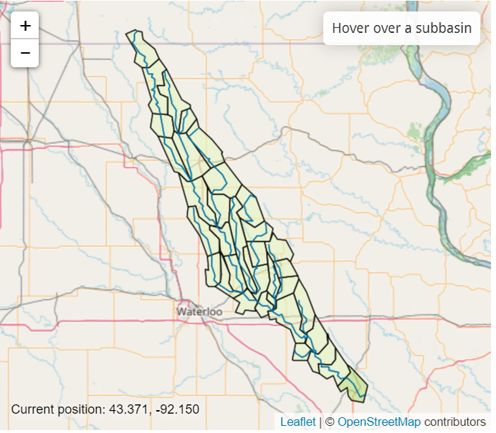

Figure 1. Location of the HUC-12- 07080102 in Iowa.

Table 1. Proportion of cropping fields to the watershed area.

|  |  |
| --- | --- |
| Cropping field | Percent of watershed |
| Corn | 25.18 |
| Corn/soybean rotation | 23.47 |
| Soybean | 0.10 |
| Soybean/corn rotation | 24.81 |

**Studied scenarios**

The study analyzed four land management and two climate change scenarios from the Hadley General Circulation Model (GCM). The land management scenarios considered were the current farmers practice tillage (hereafter called baseline tillage) and other three different tillage practices (Table 2). One of the tillage builds on the baseline tillage and allows removal of biomass from corn and soybean fields, which is practiced by some farmers. The other two tillage scenarios are conservation tillage and conservation tillage with cover crop using rye grass. Conservation tillage is an agricultural practice that reduces soil disturbance and enhances soil crop residue on the soil surface. The fourth scenario considers conservation tillage plus cover crop with rye grass in periods where there was not crop production. Use of cover crop like rye grass is recommended to reduce soil erosion and nutrient loss from the soil.

Table 2. Studied land management scenarios in different fields in the HUC-07080102 watershed.

|  |  |  |  |  |
| --- | --- | --- | --- | --- |
| **Scenarios** | **Corn fields** | **Corn/ Soybean rotation fields** | **Soybean fields** | **Soybean/Corn rotation** |
| Baseline tillage | Generic Spring Plowing Operation | CORN: Generic Spring Plowing Operation | Generic Spring Plowing Operation | SOY: Generic Spring Plowing Operation |
|  |  | SOY: Generic Fall Plowing Operation |  | CORN: Generic Spring Plowing Operation |
| Baseline tillage with residue removed | Generic Spring Plowing Operation | CORN: Generic Spring Plowing Operation | Generic Spring Plowing Operation | SOY: Generic Spring Plowing Operation |
|  | Biomass harvested | SOY: Generic Fall Plowing Operation |  | CORN: Generic Spring Plowing Operation |
|  |  | Biomass harvested | Biomass harvested | Biomass harvested |
| Conservation tillage | Generic conservation till (on ALL corn fields) | Generic conservation till | Generic Spring Plowing Operation | Generic No-till Mixing |
| Conservation tillage with cover crop | Generic conservation till (on ALL corn fields) + RYE | Generic Conservation till + RYE | Generic Spring Plowing Operation + RYE | Generic No-till Mixing +RYE |

The climate change scenario was based on the Hadley Centre HadCM2 climate change outputs for the 4.5 and 8.5 Representative Concentration Pathways (RCPs). Based on the scenario definition of the Intergovernmental Panel on Climate Change (IPCC), RCP 4.5 is described as an intermediate climate change scenario while RCP 8.5 is generally considered as the basis for worst-case climate change scenario. The climate change analysis was conducted for 30 years’ time period based on recommendation from the World Meteorological Organization (WMO, 2017). The historical climate spans for the period 1989 to 2018 while the climate change was studied for the near-term future of 2021-2050. The analysis of the climate data based on Hadley climate model for the 4.5 and 8.5 RCPs showed that precipitation may decrease and temperature may increase in the coming three decades (Figure 2). The 8.5 RCP showed drier and hotter condition as compared to the 4.5 RCP (Figure 2). 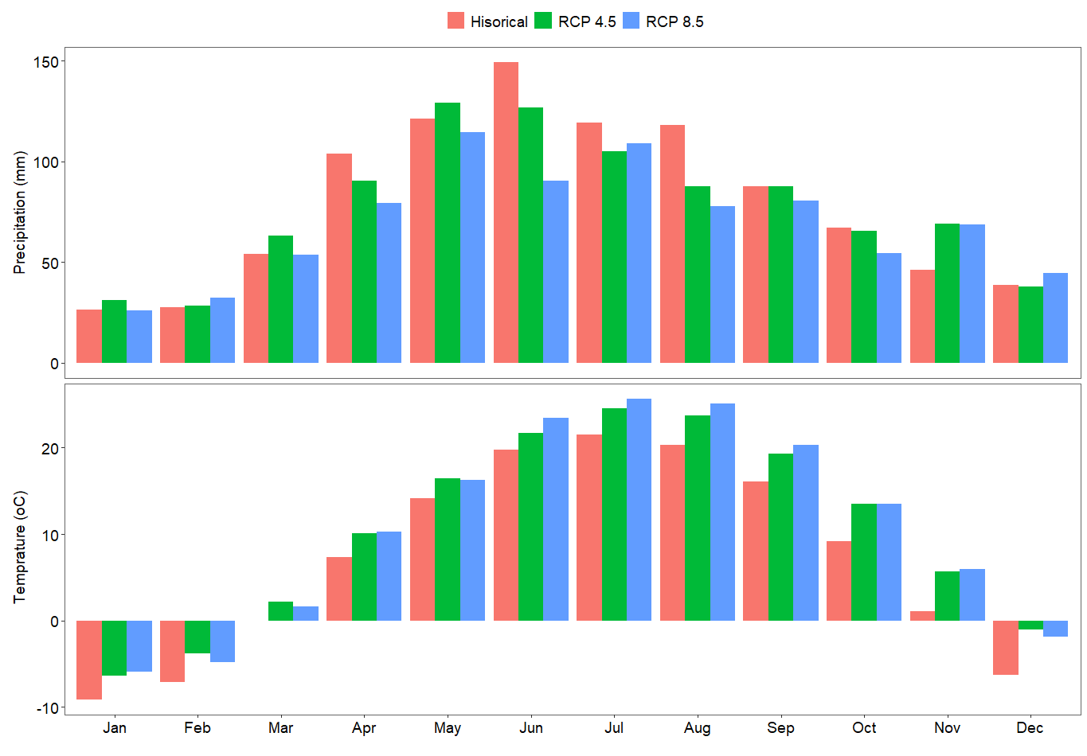Figure 2. Long-term average monthly precipitation (mm) and temperature (oC) for the historical (1984-2018) and future (2021-2050) climate conditions. The future climate was projected using the Hadley climate model based on 4.5 and 8.5 representative concentration pathways (RCP) scenarios.

**Impacts of land land management** s**cenarios with baseline climate**

Evaluation of the impact of the different tillage practices showed that conservation tillage practices caused substantial reduction on pollution (i.e. soil erosion, and nutrient) releases at the watershed outlet (Figure 3). Conservation tillage with crop cover of rye grass caused the highest reduction in sediment yield at the watershed outlet. Analysis over the long-term climate period of 1989-2018 showed that conservation tillage with crop cover may reduce the average long-term annual sediment yield by 21.8% as compared to baseline tillage (Figure 3). While the conservation tillage without any crop cover may reduce the sediment yield over the same time period by 4% compared to the baseline tillage (Figure 3). The baseline tillage with biomass harvested showed negligible impact on the long-term sediment yield at the watershed outlet compared to the baseline tillage. Likewise, conservation tillage with crop cover caused the highest reduction in total nitrogen loss at the watershed outlet followed by conservation tillage without any crop cover. Over the long-term, conservation tillage with and without crop cover caused 35% and 19% reduction in the average annual total nitrogen loss compared to the case with baseline tillage, respectively. The scenario with baseline tillage with biomass harvested caused about 2.5% reduction in the average annual total nitrogen loss compared to the baseline tillage. In the baseline tillage with biomass harvested scenario, the reduction in the nitrogen loss may be related to the removal of nitrogen with the biomass. Similarly, conservation tillage with crop cover caused the highest reduction in total phosphorous loss at the watershed outlet. Compared to the baseline tillage, the conservation tillage with crop cover caused a reduction of the long-term average annual total phosphorus by ~22% at the watershed outlet. The conservation tillage without any crop cover was not that effective in reducing total phosphorus at the watershed outlet; it only causes ~1% reduction in the long-term average annual total phosphorus loss compared to the baseline tillage. While the baseline tillage with biomass harvested increased the long-term phosphorus loss by 1.2%.

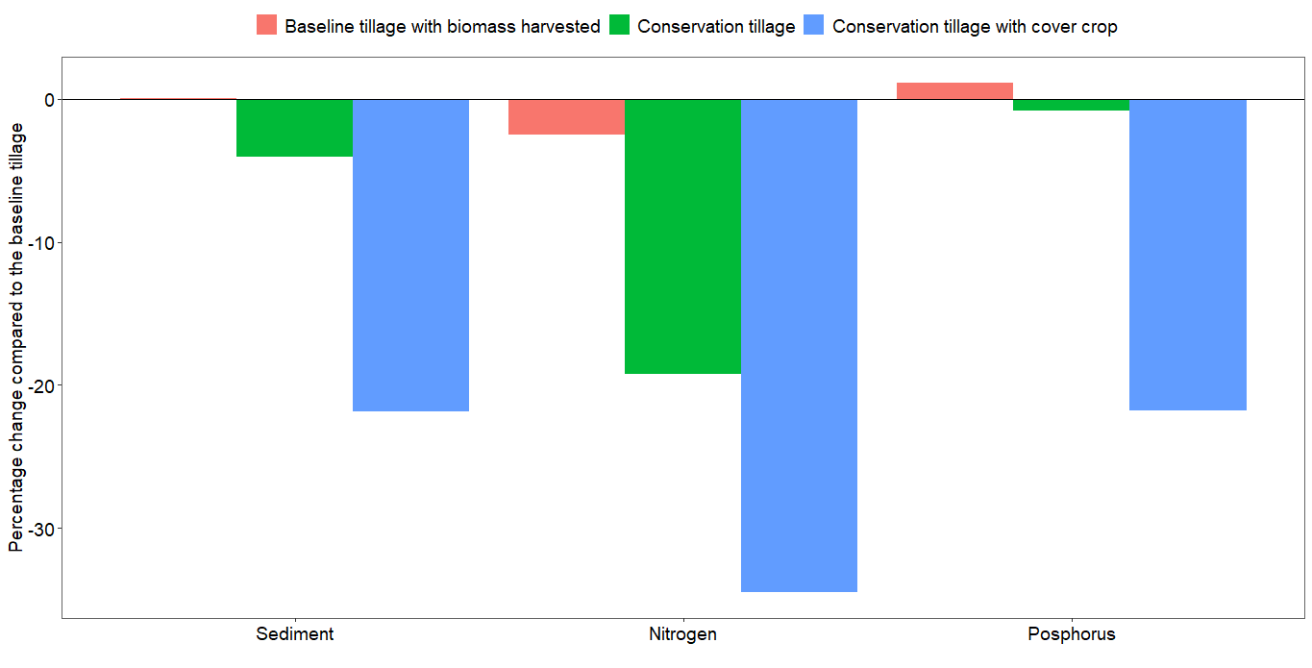 Figure 3. Percent change on long-term annual soil erosion, total nitrogen and total phosphorous loss at the watershed outlet for the baseline climate condition (1989-2018) compared to the baseline tillage.

**Impact of climate change scenarios on water resources availability**

Assessment of the impact of climate change on water resources availability using the Hadly model climate change data for the 4.5 and 8.5 RCP showed that climate change may reduce the water resources availability in the HUC-12- 07080102 watershed (Figure 4). For example, the ratio of long-term streamflow to precipitation over the watershed may reduce from 19% in the historical climate condition (1989-2018) to 9% in the 4.5 RCP scenario. This, in part, may occur due to the decrease in precipitation (Figure 2) and an increase in evapotranspiration. The long-term evapotranspiration to precipitation ratio over the watershed in the historical climate was 60% while in the 8.5 RCP was 71%. Timeseries analysis also showed that the streaflow at the watershed outlet may reduce signifcantly due to the impact of climate change (Figure 5). The long-term average daily streamflow for the historical time period was ~19.5 m3/sec, which may reduce by ~49% and ~64% for the 4.5 and 8.5 RCP climate change scenarios in the near-term future of 2021-2050, respectively.

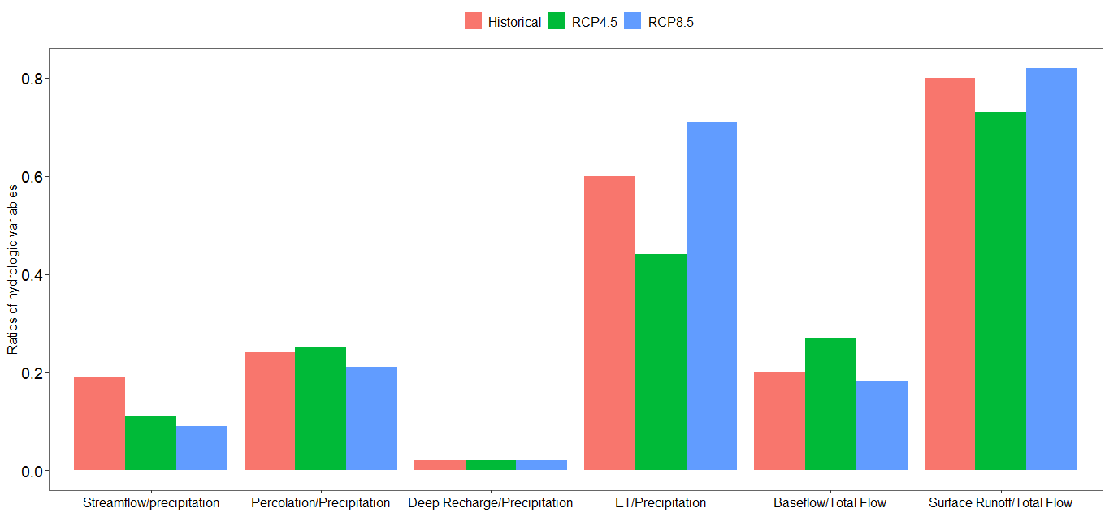

Figure 4. Water resources partitioning for HUC-12- 07080102 watershed using simulated results based on the long-term historical (1989-2018) and near-term future (2021-2050) climate data. The future climate data was based on the Hadley climate model 4.5 and 8.5 representative concentration pathway scenarios. 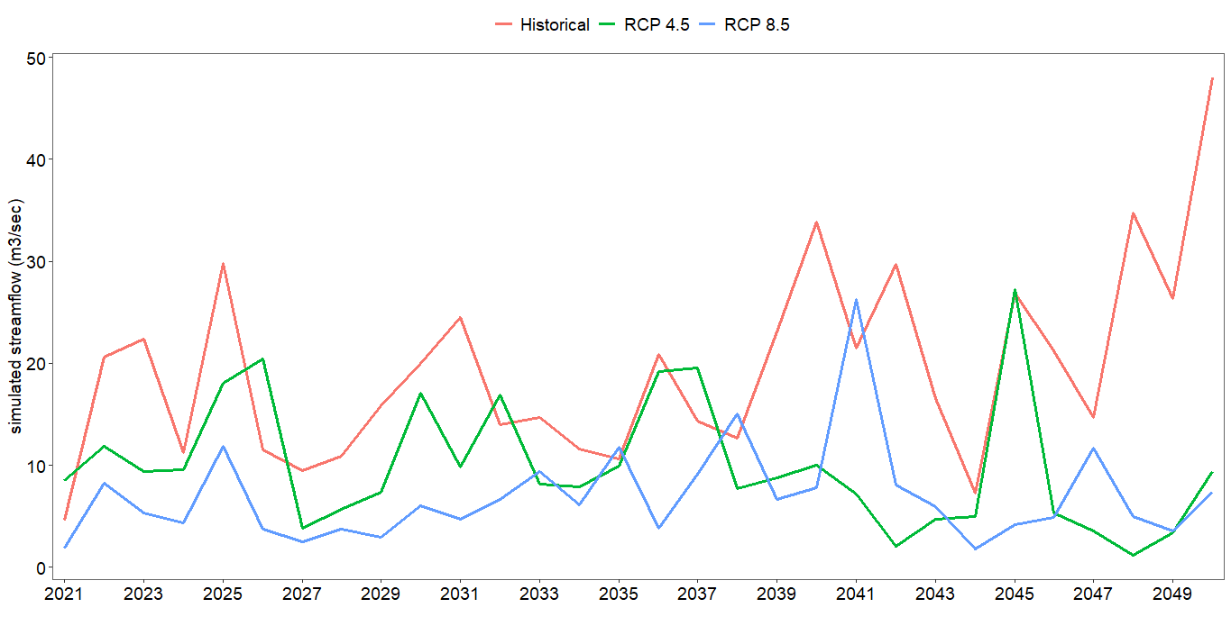

Figure 5. Simulated annual streamflow at the watershed outlet using historical climate (1989-2018) and projected climate using 4.5 and 8.5 Representative Concentration Pathways (RCPs) of the Hadley model for the near-term future (2021-2050).

**Impacts of land management scenarios under climate change scenarios**

The conservation tillage with crop cover followed by conservation tillage without crop cover ensured better environmental conditions than the current farmers practice under the influence of climate change scenarios (Figure 6). Compared to the baseline tillage, conservation tillage with crop cover and conservation tillage without crop cover reduced the long-term average annual soil erosion by ~28% and ~8%, respectively in the 4.5 RCP climate change scenario. However, the baseline tillage where the biomass was harvested caused marginal (0.8%) increase in soil erosion. Likewise, the conservation tillage with crop cover and conservation tillage without crop cover reduced the long-term average annual total nitrogen loss at the watershed outlet by ~39% and ~16% compared to the baseline tillage, respectively in the 4.5 RCP climate change scenario. The baseline tillage where the biomass was harvested may reduce the long-term average annual total nitrogen loss by ~2% as compared to the baseline tillage in the 4.5 RCP climate change scenario. As described previously, the reduction of total nitrogen loss with the baseline tillage with biomass harvested scenario may be related to nitrogen removal with the biomass. The conservation tillage with crop cover reduced the long-term average annual total phosphorus loss at the watershed outlet by ~27% compared to the baseline tillage in the 4.5 RCP climate change scenario. However, the conservation tillage without crop cover increased the long-term total phosphorus loss to the watershed outlet by ~5% in the 4.5 RCP climate change scenario. The baseline tillage where the biomass was harvested may also increase the long-term average annual total phosphorus loss by ~3% as compared to the baseline tillage in the 4.5 RCP climate change scenario.

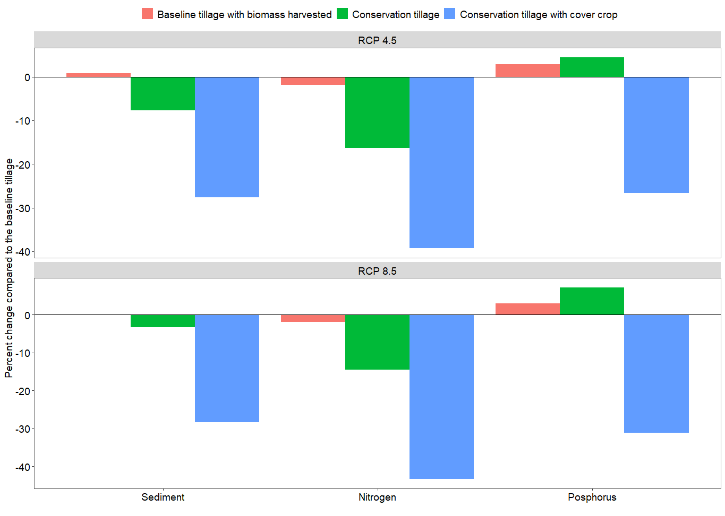 Figure 6. Percent change on long-term average annual soil erosion, total nitrogen and total phosphorus losses at the watershed outlet of the baseline scenario with biomass harvested, conservation tillage and conservation tillage with crop cover compared to continuing the baseline tillage in the plausible climate change scenario of the 4.5 and 8.5 representative concentration pathway (RCP) of the Hadley model.

Like the baseline climate condition and climate change output of RCP 4.5 scenario, the conservation tillage with crop cover caused the highest reduction in soil erosion and nutrient release with the simulations using the RCP 8.5 climate change scenario of the Hadley model (Figure 6). For example, the simulated long-term sediment yield at the watershed outlet with the conservation tillage with crop cover scenario reduced by ~29% compared to baseline tillage when simulated with climate change scenarios of 8.5 RCP. Also with the scenario of conservation tillage without crop cover, the simulated sediment yield reduced by ~3% compared to continuing baseline tillage for the near-term future of 2021-2050, and assuming a climate change scenario of Hadley model of 8.5 RCP. Likewise, the conservation tillage with crop cover and simulations with climate change scenario of the 8.5 RCP reduced the long-term average annual total nitrogen loss at the watershed outlet by ~43% compared to continuing the baseline tillage for the coming near-term climate change scenario of Hadley model of 8.5 RCP. For the same climate change scenario, the conservation tillage without crop cover reduced the long-term average annual total nitrogen loss at the watershed outlet by 15% compared to continuing the baseline tillage practice. The baseline tillage with biomass harvested also reduced the long-term average annual total nitrogen loss by 1.9% as compared to the baseline tillage scenario. Similar to the long-term sediment yield and total nitrogen loss, the conservation tillage with crop cover caused the highest total phosphorus reduction. For example, it reduced the long-term average annual total phosphorus loss at the watershed outlet by 31% compared to continuing the baseline tillage for the coming 30 years (2021-2050) with a plausible climate change scenario of Hadley model 8.5 RCP. A management scenario of conservation tillage without crop cover and baseline tillage with biomass harvested increased the simulated long-term average annual total phosphorus loss by 5% and 3%, respectively compared to continuing the baseline tillage for the coming 30 years (2021-2050) with plausible climate change scenario of the Hadley model 8.5 RCP.

**Policy suggestions**

Watershed analysis in the HUC-12-07080102 in Upper Wapsipinicon, Iowa, showed that conservation measure plays a key role in reducing environmental policy both in the current anc changed climate conditions. Conservation tillage with crop cover was found to be the best tillage practice that reduces soil erosion and release of nutrients into freshwater systems. Such practices help to maintain the heath of the soil and thereby increase agricultural and ecosystem productivity. Moreover, they help to maintain healthy freshwater ecosystems downstream. Simulations with plausible climate change data based on outputs from the Hadley model for the 4.5 and 8.5 representative concentration pathway (RCP) scenarios showed a reduction in the available water resources in the watershed. The reduction in water resources is due to decrease in rainfall and increase in evapotranspiration. The reductions in surface runoff caused a corresponding reduction in pollutant release to the watershed outlet for the four land management scenarios.

Major policy recommendations, therefore, include:

* Funding for continued and increased conservation programs is essential in both in the current and changed climate conditions.
* Policy-makers should consider developing policy options that promote conservation tillage, especially with cover crop, to improve agricultural and ecosystem productivity in upstream areas, and ensure thriving ecosystems downstream areas.

**References**

Arnold, J.G., Srinivasan, R., Muttiah, R.S., Williams, J.R., 1998. Large area hydrologic modeling and assessment part I: model development. Journal of American Water Resources Association 34, 73–89.

HAWQS, 2019. HAWQS User Guide Prepared by the Spatial Sciences Laboratory Texas A&M AgriLife Research College Station, TX For the Office of Water, Immediate Office US Environmental Protection Agency Washington, DC.

Srinivasan, R., Zhang, X., Arnold, J., 2010. SWAT ungauged: Hydrological budget and crop yield predictions in the upper Mississippi River basin. Transactions of the ASABE 53, 1533–1546. https://doi.org/10.13031/2013.34903

WMO, 2017. WMO Guidelines on the Calculation of Climate Normals. WMO 18.