**CONSERVATION IMPACT**

**IN THE UPPER SANGAMON, ILLINOIS WATERSHED**

**Impacts of land management and climate change scenarios**

**in the HUC-12- 07130006 watershed in Upper Sangamon, Illinois**

**Key Findings**

* Conservation tillage practices were effective in reducing soil erosion and limiting nutrient loss from the Upper Sangamon watershed, Illinois. The most effective intervention to reduce soil erosion and nutrient losses was the conservation tillage with crop cover both in the historical climate and climate change scenarios.
* Conservation tillage with crop cover may reduce the long-term average sediment yield by 19-21% and total nitrogen loss by 21-22% at the watershed outlet compared to continuing the current farmers’ (baseline) tillage practice.
* Climate change may increase the water resources availability in the HUC-12-07130006 Upper Sangamon watershed. The increase in water resources availability is related to an increase in precipitation. For example, based on the Hadley model 4.5 and 8.5 representative concentration pathways (RCPs) scenarios, the average annual streamflow at the watershed outlet may increase by 50-60% compared to the historical climate.
* The baseline tillage with biomass harvested scenario may increase soil erosion and total phosphorus loss both in the historical climate and future climate change scenarios. Compared to the baseline tillage, the baseline tillage with biomass harvested may increase the long-term average annual sediment yield by 1-3%, and total phosphorus loss by 2-6%. However, baseline tillage with biomass harvested may reduce the long-term average annual total nitrogen loss by ~12%.
* The findings suggest that policy options that promote conservation tillage with cover crop may help to enhance agricultural productivity in upstream areas and reduce pollution in downstream freshwater systems.

**Introduction**

The objective of this project is to estimate the impact of different land management practices and climate change on water quantity and quality in the HUC-12-07130006 Upper Sangamon watershed, Illinois. The analysis was conducted using the Hydrologic and Water Quality System (HAWQS) framework, which uses the Soil and Water Assessment Tool (SWAT) as its core modeling engine (HAWQS, 2019). SWAT is a physically-based model developed to predict the impact of land management practices on water, sediment and nutrients in watersheds having different soils, land use and management conditions (Arnold et al., 1998; Srinivasan et al., 2010). HAWQS uses hydrologic unit codes (HUCS) to run simulations.

**About the watershed**

The HUC-12- 07130006 watershed is located in Upper Sangamon in Illinois (Figure 1). The watershed has a catchment area of 3,732 km2. About 40% the watershed was cultivated with corn and 38.7% was cultivated with soybean (Table 1). The HUC SWAT model setup provided 41 subbasins and 878 Hydrological Response Units (HRUs). HRUs are the smallest units in the SWAT model which has unique combinations of land use, soil and slope class. The model was simulated for the historical time period of 1989 to 2018. The agricultural fields in the watershed have four forms of cropping pattern (i.e. some of the fields were dedicated to individual corn and soybean crop cultivations while some fields used for crop rotations between corn and soybean) (Table 1).

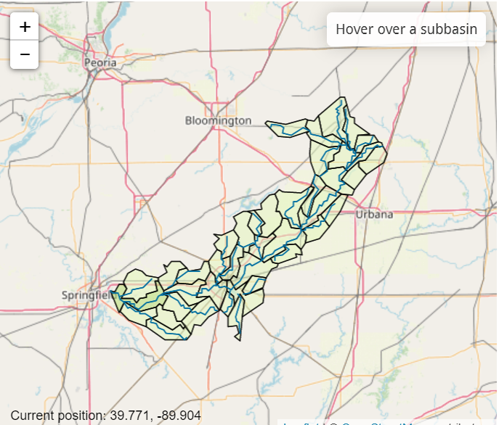

Figure 1. Location of the HUC-12- 07130006 in Upper Sangamon, Illinois.

Table 1. Proportion of cropping fields to the watershed area.

|  |  |
| --- | --- |
| Cropping field | Percent of watershed |
| Corn | 11.67 |
| Corn/soybean rotation | 28.33 |
| Soybean | 0.36 |
| Soybean/corn rotation | 38.34 |

**Studied scenarios**

The study analyzed four land management and two climate change scenarios from the Hadley General Circulation Model (GCM). The land management scenarios considered were the current farmers’ practice (hereafter called baseline) tillage and other three different tillage practices (Table 2). One of the tillage builds on the baseline tillage and allows removal of biomass from corn and soybean fields, which is practiced by some farmers. The other two tillage scenarios are conservation tillage and conservation tillage with cover crop using rye grass. Conservation tillage is an agricultural practice that reduces soil disturbance and enhances soil crop residue on the soil surface. The fourth scenario considers conservation tillage plus cover crop with rye grass in periods where there was not crop production. Use of cover crop like rye grass is recommended to reduce soil erosion and nutrient loss from the soil.

Table 2. Studied land management scenarios in different fields in the HUC-07080102 Upper Sangamon watershed.

|  |  |  |  |  |
| --- | --- | --- | --- | --- |
| **Scenarios** | **Corn fields** | **Corn/ Soybean rotation fields** | **Soybean fields** | **Soybean/Corn rotation** |
| Baseline tillage (current farmers’ practice) | No till (<1% of the watershed); reduced tillage (~10% of watershed); conservation tillage (~1%) | No till (<2.5% of watershed); reduced tillage (~24%); conservation tillage (<1%) | No till (<1% of watershed); reduced tillage (<1%); conservation tillage (<1%) | No till (6.7% of watershed); reduced tillage (25%); conservation tillage (~6.5%) |
|  |  |  |  |  |
| Baseline tillage with residue removed | Baseline tillage with biomass harvested | Baseline tillage with biomass harvested | Baseline tillage with biomass harvested | Baseline tillage with biomass harvested |
|  |
| Conservation tillage | Generic conservation tillage | Generic conservation tillage | Generic conservation tillage | Generic conservation tillage |
| Conservation tillage with cover crop | Generic conservation till with cover crop of rye grass | Generic conservation till with cover crop of rye grass | Generic conservation till with cover crop of rye grass | Generic conservation till with cover crop of rye grass |

The climate change scenarios were based on the Hadley Centre HadCM2 climate change outputs for the 4.5 and 8.5 Representative Concentration Pathways (RCPs). Based on the scenario definition of the Intergovernmental Panel on Climate Change (IPCC), RCP 4.5 is described as an intermediate climate change scenario while RCP 8.5 is generally considered as the basis for worst-case climate change scenario. The climate change analysis was conducted for 30 years’ time period based on recommendation from the World Meteorological Organization (WMO, 2017). The historical climate spans for the period 1989 to 2018 while the climate change was studied for the near-term future of 2021-2050. The analysis of the climate data based on Hadley climate model for the 4.5 and 8.5 RCPs showed that monthly precipitation may slightly increase while the average monthly temperature may consistently increase in the coming three decades (Figure 2). The long-term average annual precipitation for the historical (1989-2020), near-term future climate based on 4.5 RCP, and 8.5 RCP may be 987 mm, 1023 mm and 990 mm, respectively.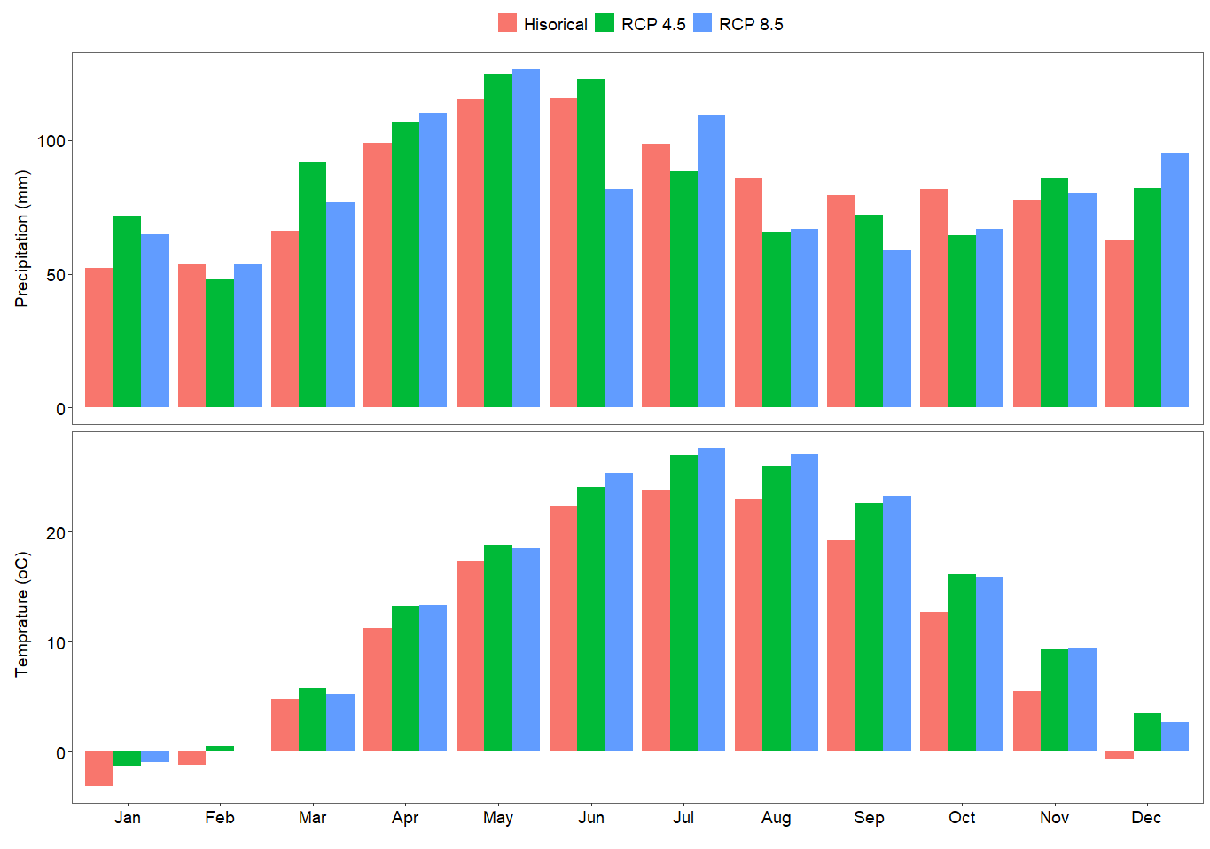Figure 2. Long-term average monthly precipitation (mm) and temperature (oC) for the historical (1984-2018) and future (2021-2050) climate conditions in the HUC-07080102 Upper Sangamon watershed. The future climate was projected using the Hadley climate model based on 4.5 and 8.5 representative concentration pathways (RCP) scenarios.

**Impacts of land land management** s**cenarios with historical (baseline) climate**

Evaluation of the impact of the different tillage practices showed that conservation tillage practices caused substantial reduction on pollution (i.e. soil erosion, and nutrient) releases at the watershed outlet (Figure 3). Conservation tillage with crop cover of rye grass caused the highest reduction in sediment yield at the watershed outlet. Analysis over the long-term climate period of 1989-2018 showed that conservation tillage with crop cover may reduce the average long-term annual sediment yield by 22% as compared to the baseline tillage (Figure 3). While the conservation tillage without any crop cover may reduce the sediment yield over the same time period by 3% compared to the baseline tillage (Figure 3). The baseline tillage with biomass harvested caused a marginal (~1%) increase on the long-term sediment yield at the watershed outlet compared to the baseline tillage. Conservation tillage with crop cover caused the highest reduction in total nitrogen loss at the watershed outlet followed by baseline tillage with biomass harvested. Over the long-term, conservation tillage with crop cover caused 21% reduction in the average annual total nitrogen loss compared to the baseline tillage. Conservation tillage without crop cover, and baseline tillage with biomass harvested reduced the average annual total nitrogen loss by ~12% and 9% compared to the baseline tillage, respectively. The reduction in the nitrogen loss for the baseline tillage with biomass harvested scenario is related to the removal of nitrogen with the biomass. Similarly, conservation tillage with crop cover caused the highest reduction in total phosphorous loss at the watershed outlet. Compared to the baseline tillage, the conservation tillage with crop cover reduced the long-term average annual total phosphorus loss at the watershed outlet by ~13%. The conservation tillage without any crop cover and baseline tillage with biomass harvested increased the long-term average annual total phosphorus loss at the watershed outlet by 5.8% and 2.8%, respectively compared to the baseline tillage.

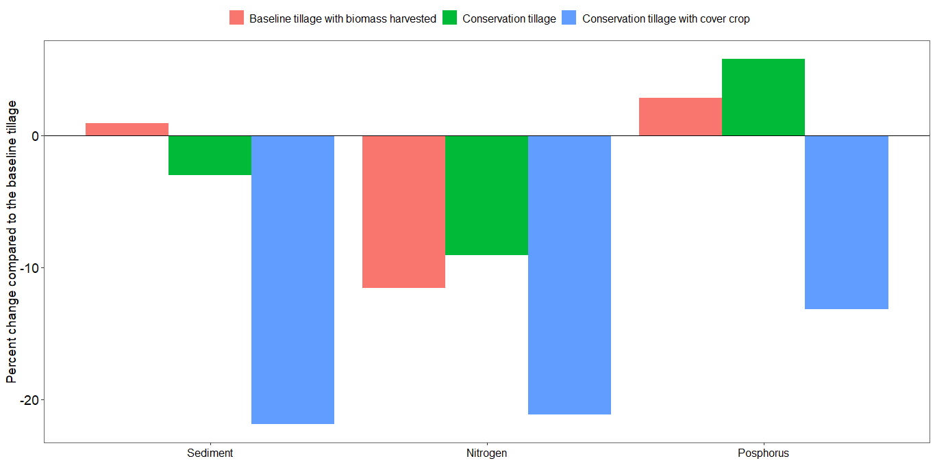Figure 3. Percent change on the long-term average annual sediment yield, total nitrogen and total phosphorous loss at the HUC-07080102 Upper Sangamon watershed outlet for the baseline climate condition (1989-2018). The percent change compared the simulations with baseline tillage with biomass harvested, conservation tillage without crop cover and conservation tillage with crop cover in relation to the farmer’s current (baseline) tillage practice. Sediment, total nitrogen and total phosphorus are major pollutants to freshwater systems.

**Impact of climate change scenarios on water resources availability**

Assessment of the impact of climate change on water resources availability using the Hadly model climate change data for the 4.5 and 8.5 RCPs scenarios showed that climate change may slightly increase the water resources availability in the HUC-12- 07130006 Upper Sangamon watershed (Figure 4). For example, the ratio of the long-term streamflow to precipitation over the watershed may increase from 33% in the historical climate condition (1989-2018) to 49% in the 4.5 RCP scenario, which may be related to the increase in precipitation (Figure 2). The long-term evapotranspiration to precipitation ratio over the watershed in the historical climate was 62% while in the 4.5 and 8.5 RCPs were 42% and 44%, respectively (Figure 4). Timeseries analysis also showed that the streaflow at the watershed outlet may increase due to the impact of climate change (Figure 5). The long-term average annual streamflow for the historical time period was ~36 m3/sec, which may increase by ~60% and ~51% for the 4.5 and 8.5 RCP climate change scenarios in the near-term future of 2021-2050, respectively.

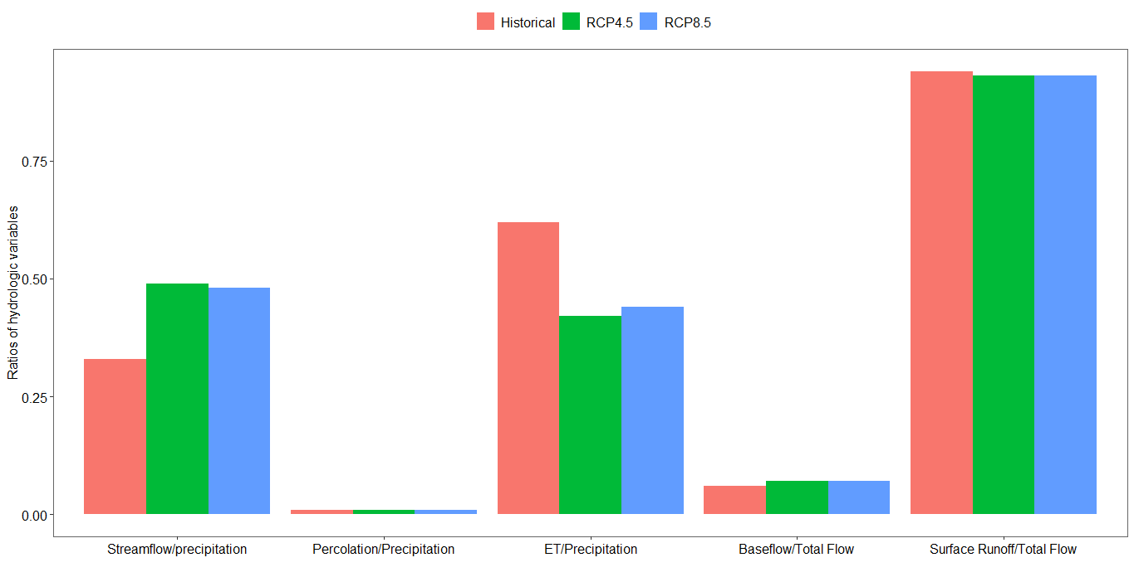Figure 4. Water resources partitioning for HUC-12- 07130006 Upper Sangamon watershed using simulated results based on the long-term historical (1989-2018) and near-term future (2021-2050) climate data. The future climate data was based on the Hadley climate model 4.5 and 8.5 representative concentration pathway (RCP) scenarios. The increase was substantial for the 4.5 RCP scenario, which in part, is related to an increase in precipitation.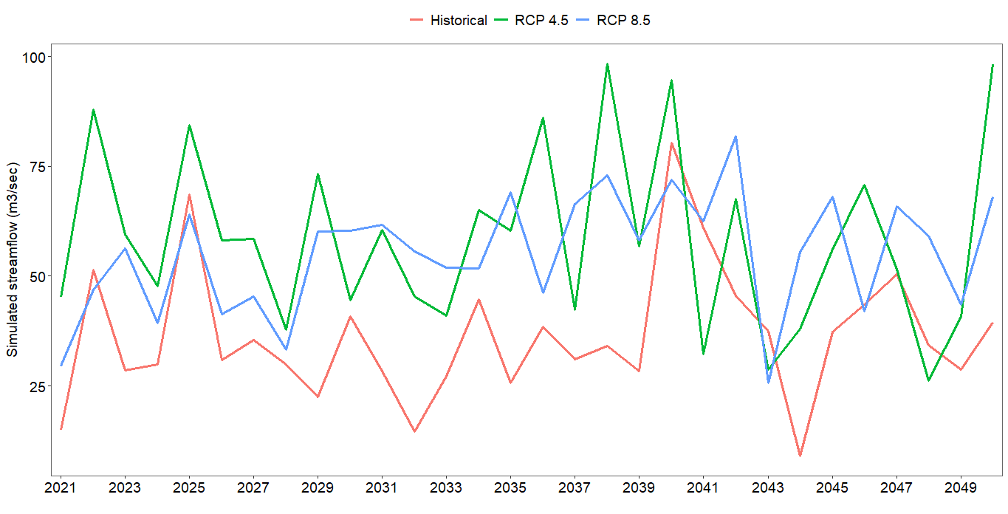Figure 5. Simulated annual streamflow at the HUC-07080102 Upper Sangamon watershed outlet using historical climate (1989-2018) and projected near-term (2021-2050) climate change data based on 4.5 and 8.5 Representative Concentration Pathways (RCPs) of the Hadley model.

**Impacts of land management scenarios under climate change scenarios**

Watershed modeling analysis using different tillage practices and climate change scenarios showed that the conservation tillage with crop cover ensures the best environmental outcomes under the influence of climate change scenarios (Figure 6). For example, compared to the baseline tillage, conservation tillage with crop cover reduced the long-term average annual soil erosion by ~19% in the 4.5 RCP climate change scenario. The other form of conservation tillage, i.e. conservation tillage without crop cover, reduced the long-term average annual soil erosion only by 1% compared to continuing the baseline tillage in the plausible climate change scenario of Hadley model 4.5 RCP. However, the baseline tillage where the biomass was harvested may increase the long-term average annual soil erosion by 3% in the plausible climate change scenario of Hadley model 4.5 RCP. Likewise, the conservation tillage with crop cover reduced the long-term average annual total nitrogen loss at the watershed outlet by ~20% compared to continuing the baseline tillage in the 4.5 RCP climate change scenario. The conservation tillage without crop cover and baseline tillage with biomass harvested reduced the long-term average annual total nitrogen loss at the watershed outlet by 11% and 12%, respectively compared to continuing the baseline tillage in the 4.5 RCP climate change scenario. The reduction of total nitrogen loss with the baseline tillage with biomass harvested scenario is related to the removal of nitrogen with the biomass. Although the extent is smaller, the conservation tillage with crop cover also may reduce the long-term average annual total phosphorus loss at the watershed outlet (~8.5%) compared to the baseline tillage in the 4.5 RCP climate change scenario. However, the conservation tillage without crop cover and baseline tillage with biomass harvested increased the long-term average annual total phosphorus loss at the watershed outlet by ~7.5% and 5.8%, respectively in the 4.5 RCP climate change scenario.

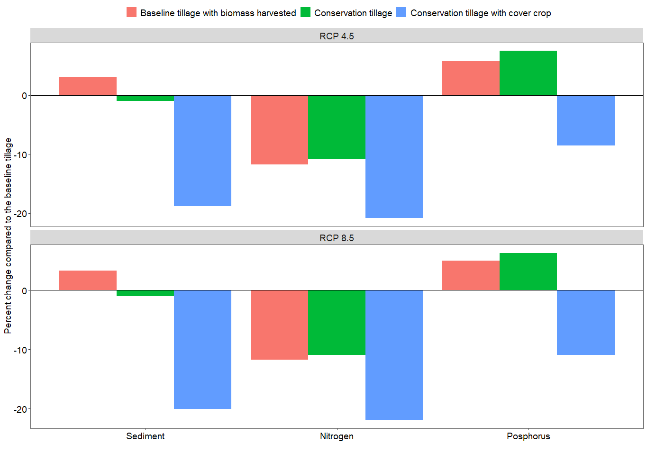 Figure 6. Percent change on the long-term average annual sediment yield, total nitrogen and total phosphorus losses at the HUC-07080102 Upper Sangamon watershed outlet of the baseline tillage scenario with biomass harvested, conservation tillage (without crop cover) and conservation tillage with crop cover compared to continuing the baseline tillage in the plausible climate change scenario of the 4.5 and 8.5 representative concentration pathway (RCPs) of the Hadley model. Sediment, total nitrogen and total phosphorus are major pollutants to freshwater systems.

Like the tillage management scenarios with the baseline climate condition and climate change output of the RCP 4.5 scenario, the conservation tillage with crop cover caused the highest reduction in soil erosion and nutrient releases with the simulations using the RCP 8.5 climate change scenario of the Hadley model (Figure 6). For example, the simulated long-term average annual sediment yield at the watershed outlet with the conservation tillage with crop cover scenario reduced by ~20% compared to the baseline tillage when simulated with climate change scenarios of 8.5 RCP. The conservation tillage without crop cover scenario only reduced the long-term average annual sediment yield only by 1% compared to continuing the baseline tillage for the near-term future of 2021-2050 while considering the plausible climate change scenario of Hadley model 8.5 RCP. Likewise, the conservation tillage with crop cover and simulations with climate change scenario of the 8.5 RCP of the Hadley model may reduce the long-term average annual total nitrogen loss at the watershed outlet by ~22% compared to continuing the baseline tillage for the same climate change scenario. The conservation tillage without crop cover and baseline tillage with biomass harvested may reduce the long-term average annual total nitrogen loss at the watershed outlet by 11% and 12%, respectively compared to continuing the baseline tillage practice for the same climate change scenario. Similar to the long-term sediment yield and total nitrogen loss, the conservation tillage with crop cover caused the highest total phosphorus loss reduction. For example, it reduced the long-term average annual total phosphorus loss at the watershed outlet by 11% compared to continuing the baseline tillage for the coming 30 years (2021-2050) with a plausible climate change scenario of Hadley model 8.5 RCP. A management scenario of conservation tillage without crop cover and baseline tillage with biomass harvested increased the simulated long-term average annual total phosphorus loss by 6.3% and 5%, respectively compared to continuing the baseline tillage for the coming 30 years (2021-2050) with plausible climate change scenario of the Hadley model 8.5 RCP.

**Policy recommendations**

Conservation tillage with crop cover is the best tillage practice that reduces soil erosion and release of nutrients into freshwater systems. Such practices help to maintain the heath of the soil and thereby increase agricultural and ecosystem productivity. Moreover, they help to maintain healthy freshwater ecosystems downstream. Simulations with plausible climate change data based on outputs from the Hadley model for the representative concentration pathway (RCP) 4.5 and 8.5 scenarios showed a minor increase in the available water resources in the watershed. The increase in water resources is related to an increase in precipitation, particularly in the 4.5 RCP scenario.

Major policy recommendations, therefore, include:

* Funding for continued and increased conservation programs is essential both in the current and changed climate conditions to ensure healthy environments both in the upstream and downstream areas.
* Policy-makers should consider developing policy options that promote conservation tillage, especially with cover crop, to improve agricultural and ecosystem productivity in upstream areas, and ensure thriving ecosystems in downstream areas.

**References**

Arnold, J.G., Srinivasan, R., Muttiah, R.S., Williams, J.R., 1998. Large area hydrologic modeling and assessment part I: model development. Journal of American Water Resources Association 34, 73–89.

HAWQS, 2019. HAWQS User Guide Prepared by the Spatial Sciences Laboratory Texas A&M AgriLife Research College Station, TX For the Office of Water, Immediate Office US Environmental Protection Agency Washington, DC.

Srinivasan, R., Zhang, X., Arnold, J., 2010. SWAT ungauged: Hydrological budget and crop yield predictions in the upper Mississippi River basin. Transactions of the ASABE 53, 1533–1546. https://doi.org/10.13031/2013.34903

WMO, 2017. WMO Guidelines on the Calculation of Climate Normals. WMO 18.