**CONSERVATION IMPACT IN THE BOONE, IOWA, WATERSHED**

**Impacts of land management and climate change scenarios**

**in the HUC-12-07100005 watershed in Boone, Iowa**

**Key Findings**

* Conservation tillage practices were effective in reducing soil erosion and limiting nutrient loss from the Boone watershed, Iowa. The most effective intervention to reduce soil erosion and nutrient leaching both in the historical climate and climate change scenarios was the conservation tillage with crop cover.
* Conservation tillage with crop cover may reduce the long-term average annual sediment yield by 5-8%, total nitrogen loss by 16-24%, and total phosphorus loss by 7-13% at the watershed outlet compared to continuing the current farmers’ (baseline) tillage practice.
* Climate change may decrease the water resources availability in the HUC-12-07100005 Boone watershed. Based on the Hadley model 4.5 and 8.5 representative concentration pathways (RCPs) scenarios, the average annual streamflow at the watershed outlet may decrease by 16-44% compared to the historical climate.
* Because of the reduction of surface runoff in the projected climate scenarios, the soil erosion and nutrient leaching (such as nitrogen and phosphorus) were smaller as compared to the historical climate, which helped to enhance the efficiency of the soil conservation practices in reducing these pollutants.
* The findings suggest that policy options that promote conservation tillage with cover crop may help to enhance agricultural productivity in upstream areas and reduce pollution in downstream freshwater systems.

**Introduction**

The objective of this project is to estimate the impact of different land management practices and climate change on water quantity and quality in the HUC-12-07100005 Boone watershed, Iowa. The analysis was conducted using the Hydrologic and Water Quality System (HAWQS) framework, which uses the Soil and Water Assessment Tool (SWAT) as its core modeling engine (HAWQS, 2019). SWAT is a physically-based model developed to predict the impact of land management practices on water, sediment, and nutrients in watersheds having different soils, land use, and management conditions (Arnold et al., 1998; Srinivasan et al., 2010). HAWQS uses hydrologic unit codes (HUCS) to run simulations.

**About the watershed**

The HUC-12-0710005 watershed is located in Boone in Iowa (Figure 1). The watershed has a catchment area of 2352.86 km2. About 48% the watershed was cultivated with corn and 36% was cultivated with soybean (Table 1). The HUC SWAT model setup provided 29 subbasins and 345 Hydrological Response Units (HRUs). HRUs are the smallest units in the SWAT model which has unique combinations of land use, soil, and slope class. The model was simulated for the historical time period of 1989 to 2018. The agricultural fields in the watershed have three forms of cropping pattern (i.e. some of the fields were dedicated to individual corn and soybean crop cultivations and other fields for corn and soybean rotation) (Table 1).

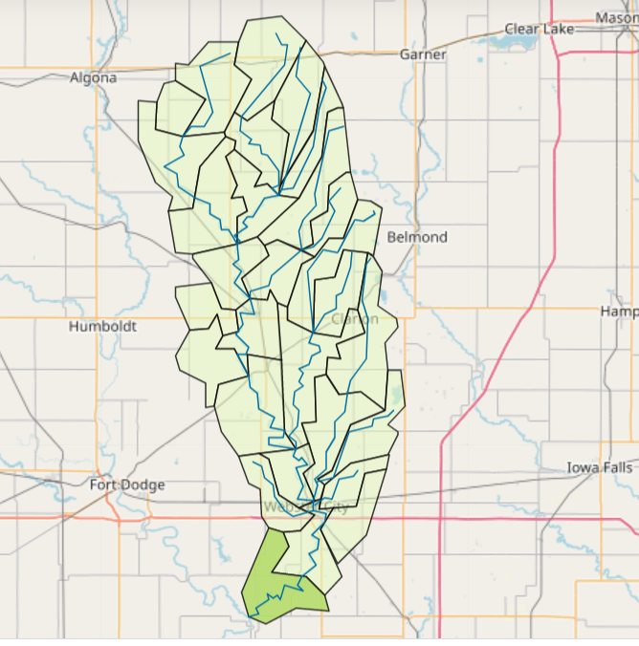

Figure 1. Location of the HUC-12-07100005 in Boone, Iowa.

Table 1. Proportion of cropping fields to the watershed area.

|  |  |
| --- | --- |
| Cropping field | Percent of watershed |
| Corn | 15.3 |
| Corn/soybean rotation | 32.7 |
| Soybean/corn rotation | 37 |

**Studied scenarios**

The study analyzed four land management and two climate change scenarios from the Hadley General Circulation Model (GCM). The land management scenarios considered were the current farmers’ practice (hereafter called baseline) tillage and other three different tillage practices (Table 2). One of the tillage builds on the baseline tillage and allows removal of biomass from corn and soybean fields, which is practiced by some farmers. The other two tillage scenarios are conservation tillage and conservation tillage with cover crop using rye grass. Conservation tillage is an agricultural practice that reduces soil disturbance and enhances soil crop residue on the soil surface. The fourth scenario considers conservation tillage plus cover crop with rye grass in periods where there was not crop production. Use of cover crop like rye grass is recommended to reduce soil erosion and nutrient loss from the soil.

Table 2. Studied land management scenarios in different fields in the HUC-12-07100005 Boone watershed.

|  |  |  |  |
| --- | --- | --- | --- |
| **Scenarios** | **Corn fields** | **Corn/ Soybean rotation fields** | **Soybean/Corn rotation** |
| Baseline tillage (current farmers’ practice) | No till (<1% of the watershed); reduced tillage (~12.2% of watershed); conservation tillage (~2%) | No till (~1% of watershed); reduced tillage (~30%); conservation tillage (~1.7%) | No till (~4.9% of watershed); reduced tillage (~22%); conservation tillage (~9.4%) |
|  |  |  |  |
| Baseline tillage with residue removed | Baseline tillage with biomass harvested | Baseline tillage with biomass harvested | Baseline tillage with biomass harvested |
|  |
| Conservation tillage | Generic conservation tillage | Generic conservation tillage | Generic conservation tillage |
| Conservation tillage with cover crop | Generic conservation till with cover crop of rye grass | Generic conservation till with cover crop of rye grass | Generic conservation till with cover crop of rye grass |

The climate change scenarios were based on the Hadley Centre HadCM2 climate change outputs for the 4.5 and 8.5 Representative Concentration Pathways (RCPs). Based on the scenario definition of the Intergovernmental Panel on Climate Change (IPCC), RCP 4.5 is described as an intermediate climate change scenario while RCP 8.5 is generally considered as the basis for worst-case climate change scenario. The climate change analysis was conducted for 30 years’ time period based on recommendation from the World Meteorological Organization (WMO, 2017). The historical climate spans for the period 1989 to 2018 while the climate change was studied for the near-term future of 2021-2050. The analysis of the climate data based on Hadley climate model for the 4.5 and 8.5 RCPs showed that the monthly precipitation for the 4.5 RCP scenario may not change significantly compared to the monthly historical climate, but the mean monthly climate for the 8.5 RCP scenario may decrease (Figure 2). The average monthly temperature for the 4.5 and 8.5 RCP scenarios may increase in the coming three decades as compared to the historical climate (Figure 2). The long-term average annual precipitation for the historical (1989-2020), near-term future climate scenarios based on the 4.5 RCP, and 8.5 RCP may be 882 mm, 881 mm, and 765 mm, respectively.

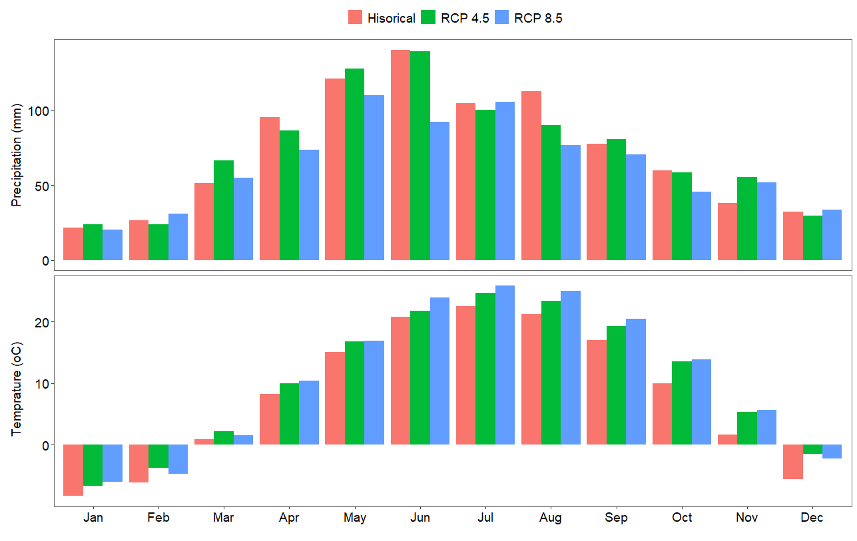

Figure 2. Long-term average monthly precipitation (mm) and temperature (oC) for the historical (1984-2018) and future (2021-2050) climate conditions in the HUC-12-07100005 Boone watershed. The future climate was projected using the Hadley climate model based on 4.5 and 8.5 representative concentration pathways (RCP) scenarios.

**Impacts of land management** s**cenarios with historical (baseline) climate**

Evaluation of the impact of the different tillage practices showed that conservation tillage practices caused substantial reduction on pollution (i.e. soil erosion, and nutrient) releases at the watershed outlet (Figure 3). Conservation tillage with crop cover of rye grass caused the highest reduction in sediment yield at the watershed outlet. Analysis over the long-term historical climate period of 1989-2018 showed that conservation tillage with crop cover may reduce the average long-term annual sediment yield by 5.6% as compared to the baseline tillage (Figure 3). The conservation tillage without any crop cover may marginally reduce the sediment yield over the same period by 0.32% compared to the baseline tillage (Figure 3). However, the baseline tillage where the biomass was harvested may marginally increase the sediment yield over the same period by 0.3% compared to the baseline tillage (Figure 3). Conservation tillage with crop cover caused the highest reduction in total nitrogen loss at the watershed. Over the long-term, conservation tillage with crop cover caused 15.8% reduction in the average annual total nitrogen loss compared to the baseline tillage. Conservation tillage without crop cover and baseline tillage with biomass harvested reduced the long-term average annual total nitrogen loss by ~5.9% and 7.8%, respectively, compared to the baseline tillage. The reduction in the nitrogen loss for the baseline tillage with biomass harvested scenario is related to the removal of nitrogen with the biomass. Similarly, conservation tillage with crop cover caused the highest reduction in total phosphorous loss at the watershed outlet. Compared to the baseline tillage, the conservation tillage with crop cover reduced the long-term average annual total phosphorus loss at the watershed outlet by ~6.8%. However, the conservation tillage without any crop cover and baseline tillage with biomass harvested increased the long-term average annual total phosphorus loss at the watershed outlet by 6.4% and 2.7%, respectively.

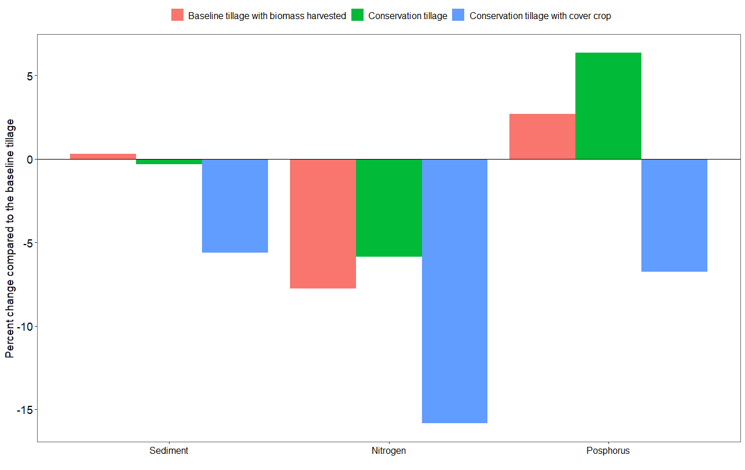

Figure 3. Percent change on the long-term average annual sediment yield, total nitrogen and total phosphorous loss at the HUC-12-07100005 Boone watershed outlet for the baseline climate condition (1989-2018). The percent change compared the simulations with baseline tillage with biomass harvested, conservation tillage without crop cover, and conservation tillage with crop cover in relation to the farmers’ current (baseline) tillage practice. Sediment, total nitrogen, and total phosphorus are major pollutants to freshwater systems.

**Impact of climate change scenarios on water resources availability**

Assessment of the impact of climate change on water resources availability using the Hadly model climate change data for the 4.5 and 8.5 RCPs scenarios showed that climate change may decrease the water resources availability in the HUC-12- 07100005 Boone watershed (Figure 4). For example, the ratio of the long-term streamflow to precipitation over the watershed may decrease from 33% in the historical climate condition (1989-2018) to 28% and 21% in the 4.5 and 8.5 RCP scenarios, respectively (Figure 2). The long-term evapotranspiration to precipitation ratio over the watershed in the historical climate was 65% while in the 4.5 and 8.5 RCPs were 69% and 77%, respectively (Figure 4). Timeseries analysis also showed that the streaflow at the watershed outlet may overall decrease due to the impact of climate change (Figure 5). The long-term average annual streamflow for the historical time period of 1989-2018 was ~23.2 m3/sec, which may decrease by ~16% and ~44% for the 4.5 and 8.5 RCP climate change scenarios in the near-term future of 2021-2050, respectively. The decrease in water resources availability is due to an increase in temprature in the 4.5 RCP scenario and a decrease in rainfall and an increase in temprature in the 8.5 RCP scenario.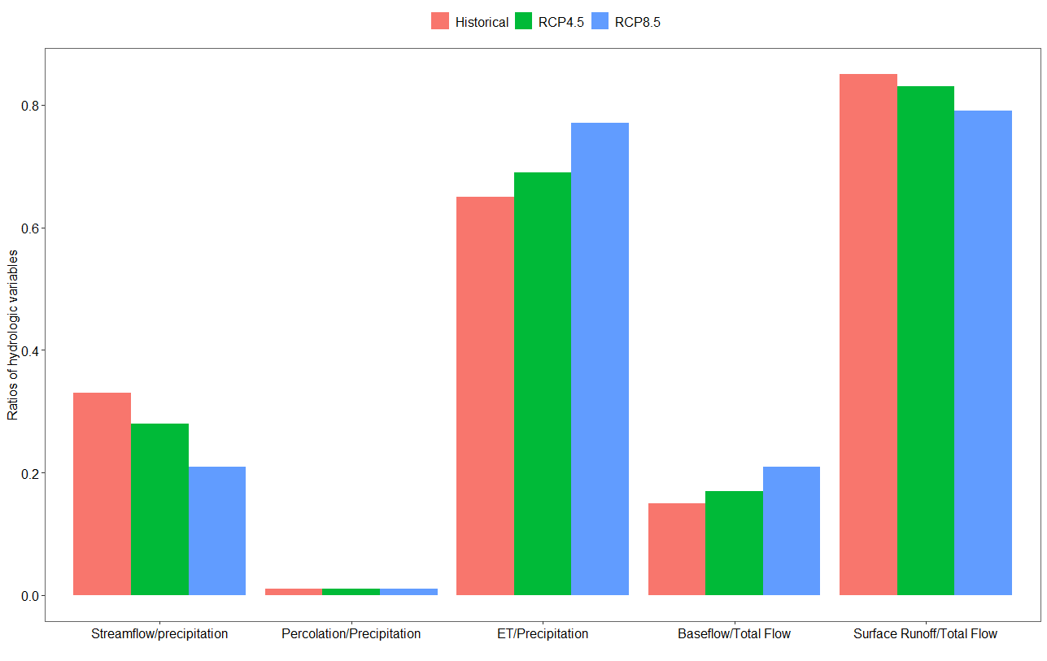 Figure 4. Water resources partitioning for HUC-12-07100005 Boone watershed using simulated results based on the long-term historical (1989-2018) and near-term future (2021-2050) climate data. The future climate data was based on the Hadley climate model 4.5 and 8.5 representative concentration pathway (RCP) scenarios.

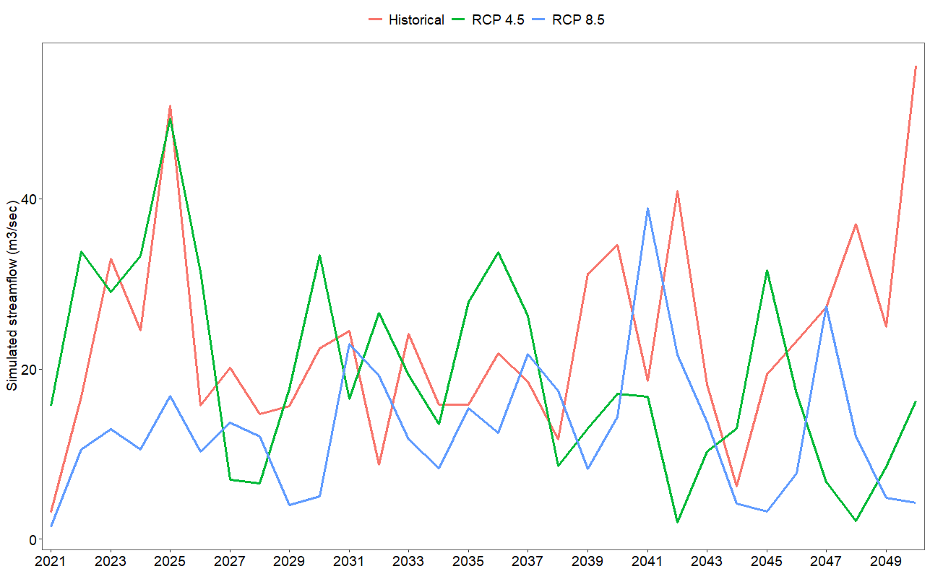

Figure 5. Simulated annual streamflow at the HUC-12-07100005 Boone watershed outlet using historical climate (1989-2018) and projected near-term (2021-2050) climate change data based on 4.5 and 8.5 Representative Concentration Pathways (RCPs) of the Hadley model.

**Impacts of land management scenarios under climate change scenarios**

Watershed modeling analysis using different tillage practices and climate change scenarios showed that the conservation tillage with crop cover ensures the best environmental outcomes under the influence of climate change scenarios (Figure 6). For example, compared to the baseline tillage, conservation tillage with crop cover reduced the long-term average annual soil erosion by ~6.5% in the 4.5 RCP climate change scenario. The conservation tillage without crop cover may slightly increase the long-term average annual soil erosion by ~0.3% compared to continuing the baseline tillage in the plausible climate change scenario of Hadley model 4.5 RCP. The baseline tillage where the biomass harvested may increase the long-term average annual soil erosion by ~4.4% compared to continuing the baseline tillage in the plausible climate change scenario of Hadley model 4.5 RCP. Likewise, the conservation tillage with crop cover reduced the long-term average annual total nitrogen loss at the watershed outlet by ~20% compared to continuing the baseline tillage in the 4.5 RCP climate change scenario. The conservation tillage without crop cover and the baseline tillage where biomass harvested may equally reduce the long-term average annual total nitrogen loss at the watershed outlet by 7.2% compared to continuing the baseline tillage in the 4.5 RCP climate change scenario. The reduction of total nitrogen loss with the baseline tillage with biomass harvested scenario is related to the removal of nitrogen with the biomass. The conservation tillage with crop cover may reduce the long-term average annual total phosphorus loss at the watershed outlet by 9.6% compared to the baseline tillage in the 4.5 RCP climate change scenario. However, both the conservation tillage without crop cover and baseline tillage with biomass harvested may increase the long-term average annual total phosphorus loss at the watershed outlet by ~5% in the 4.5 RCP climate change scenario.

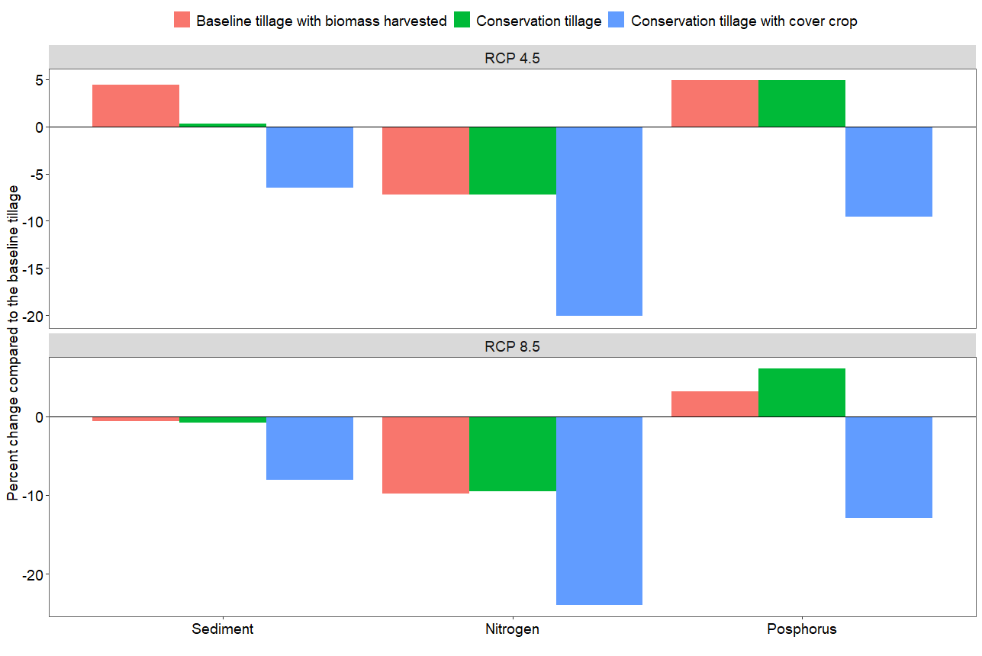

Figure 6. Percent change on the long-term average annual sediment yield, total nitrogen, and total phosphorus losses at the HUC-12-07100005 Boone watershed outlet of the baseline tillage scenario with biomass harvested, conservation tillage (without crop cover) and conservation tillage with crop cover compared to continuing the baseline tillage in the plausible climate change scenario of the 4.5 and 8.5 representative concentration pathway (RCPs) of the Hadley model. Sediment, total nitrogen, and total phosphorus are major pollutants to freshwater systems.

Like the tillage management scenarios with the baseline climate condition and climate change output of the RCP 4.5 scenario, the conservation tillage with crop cover caused the highest reduction in soil erosion and nutrient releases with the simulations using the RCP 8.5 climate change scenario of the Hadley model (Figure 6). For example, the simulated long-term average annual sediment yield at the watershed outlet with the conservation tillage with crop cover scenario reduced by ~8.1% compared to the baseline tillage when simulated with climate change scenarios of 8.5 RCP. The conservation tillage without crop cover and baseline tillage with biomass-harvested scenarios reduced the long-term average annual sediment yield by 0.8% and 0.6%, respectively, compared to continuing the baseline tillage for the near-term future of 2021-2050 while considering the plausible climate change scenario of Hadley model 8.5 RCP. Likewise, the conservation tillage with crop cover and simulations with climate change scenario of the 8.5 RCP of the Hadley model may reduce the long-term average annual total nitrogen loss at the watershed outlet by ~24% compared to continuing the baseline tillage for the same climate change scenario. The conservation tillage without crop cover and baseline tillage with biomass harvested may reduce the long-term average annual total nitrogen loss at the watershed outlet by 9.5% and 9.8%, respectively, compared to continuing the baseline tillage practice for the same climate change scenario. Similar to the long-term sediment yield and total nitrogen loss, the conservation tillage with crop cover caused the highest total phosphorus loss reduction. For example, it reduced the long-term average annual total phosphorus loss at the watershed outlet by ~13% compared to continuing the baseline tillage for the coming 30 years (2021-2050) with a plausible climate change scenario of Hadley model 8.5 RCP. A management scenario of conservation tillage without crop cover and baseline tillage with biomass harvested decreased the long-term average annual total phosphorus loss by ~6% and ~3%, respectively, compared to continuing the baseline tillage for the coming 30 years (2021-2050) with plausible climate change scenario of the Hadley model 8.5 RCP.

**Policy suggestions**

Conservation tillage with crop cover is the best tillage practice that reduces soil erosion and leaching of nutrients into freshwater systems. Such practices help to maintain the health of the soil and thereby increase agricultural and ecosystem productivity. Moreover, they help to maintain healthy freshwater ecosystems downstream. Simulations with plausible climate change data based on outputs from the Hadley model for the representative concentration pathway (RCP) 4.5 and 8.5 scenarios showed a decrease in the available water resources in the watershed.

Major policy recommendations, therefore, include:

* Funding for continued and increased conservation programs is essential both in the current and changed climate conditions to ensure healthy environments both in the upstream and downstream areas.
* Policy-makers should consider developing policy options that promote conservation tillage, especially with cover crop, to improve agricultural and ecosystem productivity in upstream areas, and ensure thriving ecosystems in downstream areas.

**References**

Arnold, J.G., Srinivasan, R., Muttiah, R.S., Williams, J.R., 1998. Large area hydrologic modeling and assessment part I: model development. Journal of American Water Resources Association 34, 73–89.

HAWQS, 2019. HAWQS User Guide Prepared by the Spatial Sciences Laboratory Texas A&M AgriLife Research College Station, TX For the Office of Water, Immediate Office US Environmental Protection Agency Washington, DC.

Srinivasan, R., Zhang, X., Arnold, J., 2010. SWAT ungauged: Hydrological budget and crop yield predictions in the upper Mississippi River basin. Transactions of the ASABE 53, 1533–1546. https://doi.org/10.13031/2013.34903

WMO, 2017. WMO Guidelines on the Calculation of Climate Normals. WMO 18.